# Week 2: Introduction to 3D Modeling - Parts

|  |  |
| --- | --- |
| **Concepts** | * An introduction to “Design Intent” * Using dimensions and constraints * Automatic inferencing * Making an accurate part * Sketching practice * Using and creating planes * Creating fillets and chamfers * Utilizing multiple sketch regions * Basic parts |
| **Models** | * Clock - used for lesson in design intent * Various simple geometric shapes |
|  | |

# Before We Get Started…

Last week, we learned about the Onshape interface, sketch-based modeling, and the four foundational features. We made a bunch of sketches and parts but didn’t worry about how big they were or how the sketch entities related to one another. This is a great way to dip your feet into the ocean that is 3D CAD… but engineers like to be precise. This week, we will learn primarily about “design intent”, an important concept that allows designers and engineers to not only accurately create the parts they need, but also design their CAD models so that it is easy to make changes down the road.

# Design Intent

In this section, we are going to build on what we’ve already learned about creating geometry in Onshape, and we are going to continue to use our 2D sketch>3D feature workflow. We are going to learn about “design intent” by way of using **Sketch Constraints** and **Dimensions**. Finally, we are also going to start building more complex parts, by utilizing sketches with multiple **Enclosed Regions**.

Most objects around us have parts and features with specific dimensions that relate in some way to one another. The designer purposefully made these decisions and relationships in order to execute their design the way they want it to. **Design Intent** is the practice of developing your project’s objectives and requirements even before working on your design. The more complex the geometry, the more we need to think about how we want to design the parts before just going ahead and making it.

It might be easier to think about design intent by reversing the words to “intended design”. Take an analog clock for example:

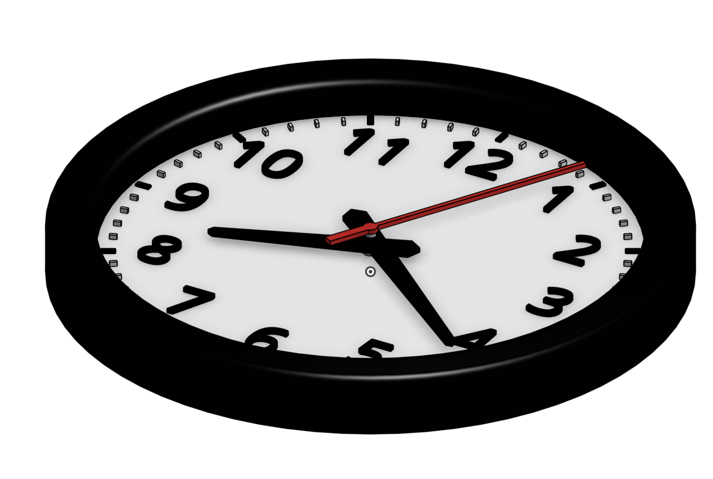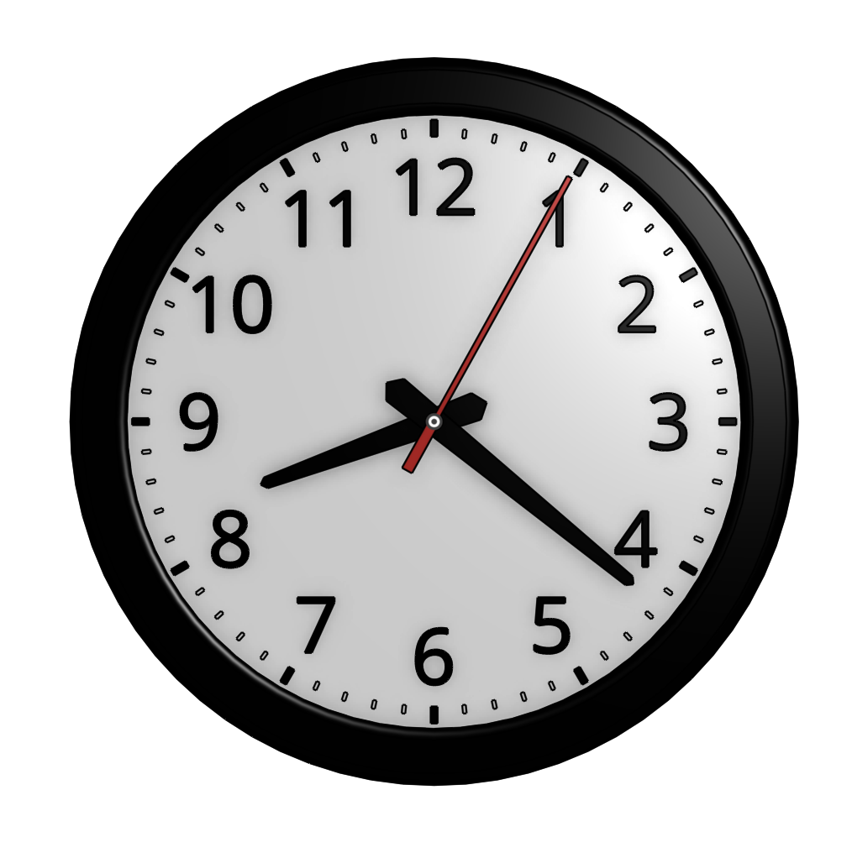

What is its “intended design?” We could say that the clock has the following design requirements:

1. The hands should always be located in the center of the clock, no matter how short the hands may be.
2. The numbers should always be equidistant from the center of the clock face, so if I move one of the numbers closer to the center, all the numbers should move closer.
3. The numbers should always have the same height, so if I make one of the numbers bigger, the rest of the numbers should also become bigger.

These kind of statements help define what the clock should look like. But how do we satisfy these design requirements in CAD? We learned that sketch-based modeling always involve 2D sketches, so let’s look at some 2D sketches first.

## Dimensions & Constraints in 2D Geometry

Design intent goes hand-in-hand with **Dimensions** and **Constraints**. Dimensions refer to the distance and angle values of sketch entities. Constraints refer to the geometric relationships and rules within a sketch.

Believe it or not, most of you will have seen these concepts before. Think back to high school geometry –remember the vocab words: *tangent*, *parallel, normal*? These concepts are directly practical here in CAD. Even a simple example, like a square, has many constraints. What are some design requirements for a square? They may be trivial but we can say the following:

1. There should first be four lines. Two lines should be vertical and two lines should be horizontal:

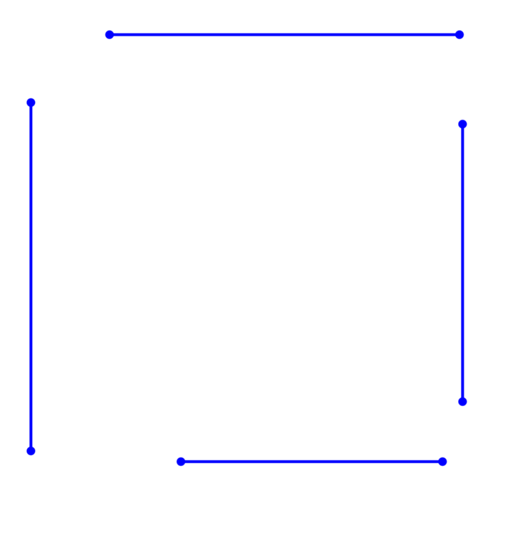

1. For the lines to touch and form a square, each end of the line should be coincident to another end:

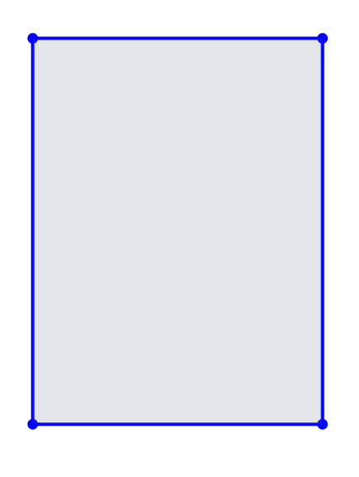

1. The lines should have equal lengths:

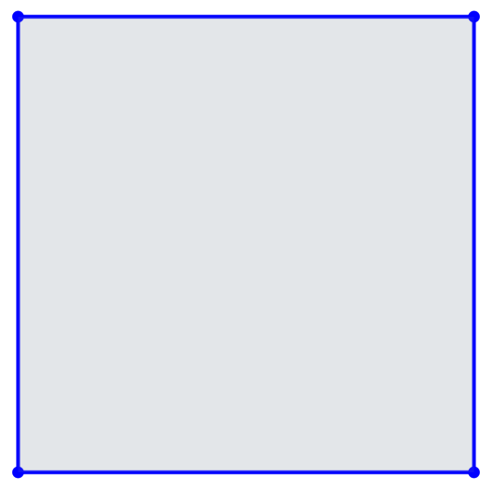

Vertical, Horizontal, Equal, and Coincident are all examples of **Constraints** in Onshape (as well as in most CAD systems) and can be used to form relationships between sketch geometry.

Now what if we wanted to draw something a little more complicated like this?:

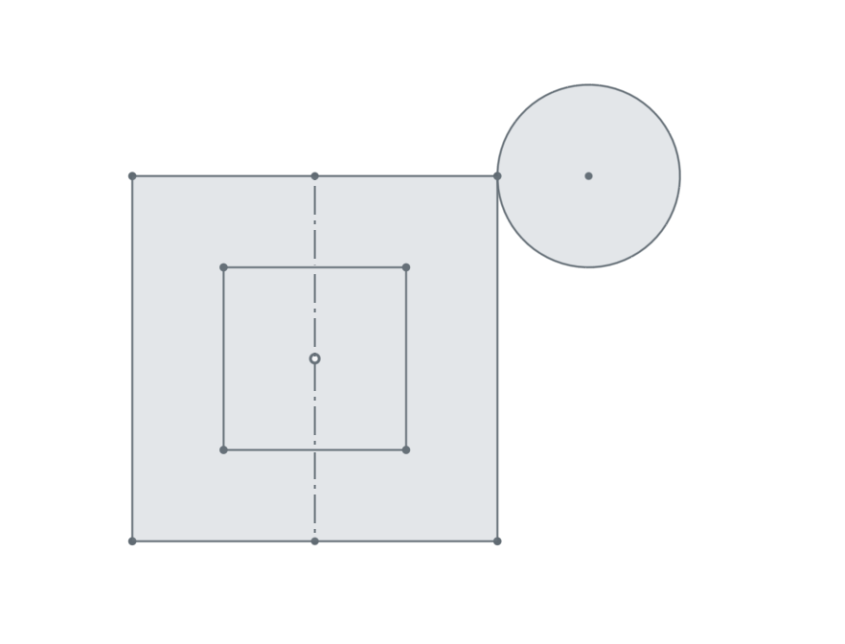

Let’s try drawing it in Onshape and see how Onshape helps you in applying some constraints:

1. Start by creating up a new document, name it “Week 2 - Constraints”, and create a sketch on the Front Plane. We’ll be using the dimension tool and the constraints which are on the right-hand side. Hover over each icon to learn more about them. Review them in the Onshape help [here](https://cad.onshape.com/help/#sketch-tools.htm%3FTocPath%3DPart%2520Studios%7CSketch%2520Tools%7C_____0). Notice that many of them are those vocabulary words you learned about in high school geometry class.

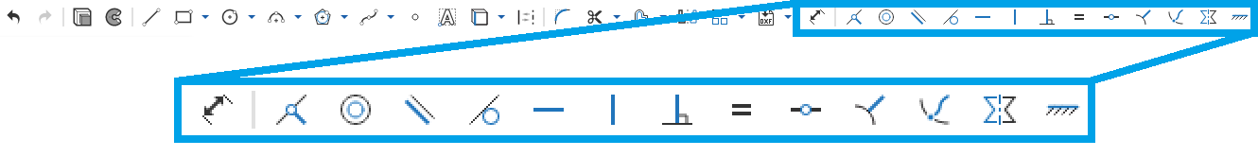

1. Start a sketch by drawing a line starting from the origin.
2. Notice that even after you draw the line, you can drag the end (highlighted below) to anywhere in the screen. This is because only one end of the line is fixed at the origin, but the other end is free to have any length and to be placed at any angle:

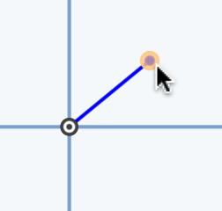

1. Try dragging the end of the line to somewhere directly above the origin. Feel free to click anywhere such that the line is dotted in orange (the line should “snap” to be vertical):

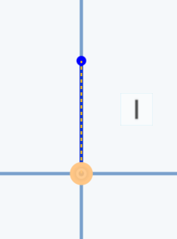

1. Last week we saw that Onshape “snaps” your lines as you go. Now we know that what Onshape is actually doing is automatically applying constraints for you. This is called Automatic Inferencing. In this case, Onshape automatically added a coincident constraint between one end of my line and the origin, and is suggesting that I add a vertical constraint to the line itself. More information can be found here: [Automatic Inferencing](https://cad.onshape.com/help/index.htm#inferencing.htm).
2. Notice that once you click again to finished making the the line, it is set it to be vertical. You can only move the end of the line up and down. You’ve applied the **Vertical** constraint.
3. We know from Week 1 that we can start a line by clicking the end of another line. Onshape does this because it assumes you want the lines to touch, i.e. you want a Coincident constraint between the two ends. Finish drawing all the edges of the soon-to-be-square. The **Horizontal** constraint should work in the same way as the Vertical. This satisfies Design Requirements A and B (two vertical and two horizontal lines, lines should be coincident).

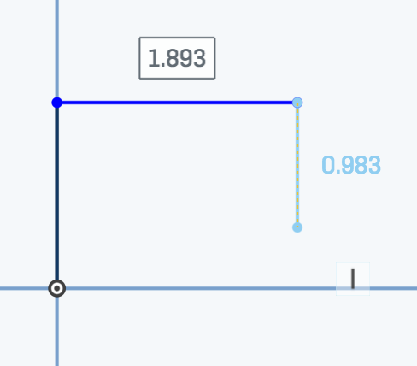

1. Now you’ll want the sides to be equal to each other. Select all four lines and click the Equal constraint . This satisfies Design Requirement C (the lines should have equal lengths):

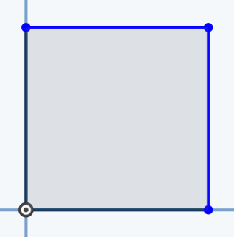

All the design requirements we’ve listed for the square is now satisfied! Let’s continue with the example:”

1. Now try dragging the top right corner. Notice that no matter how far you bring your cursor away from the origin, your sketch will *always* be a square.
2. But what if you don’t want to be able to drag your square to any size? This is where dimensions come in handy. Let’s add some dimensions to our sketch by clicking on the dimension tool . Then click on the vertical line extending from the origin. Drag away from the line. A number (not necessarily the same as the picture) should come up:

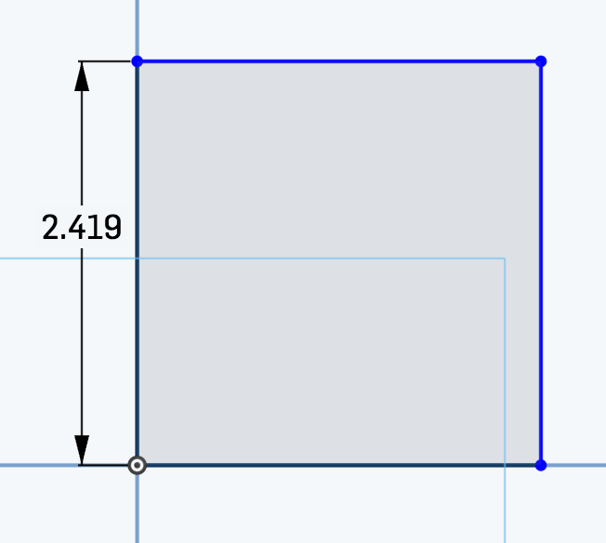

*Pro Tip: Another way to dimension the line is by first clicking on the dimension tool, and then selecting the two horizontal lines that you want to dimension between.*

1. Click anywhere next to the vertical line you’re dimensioning. The number will change into an editable box:

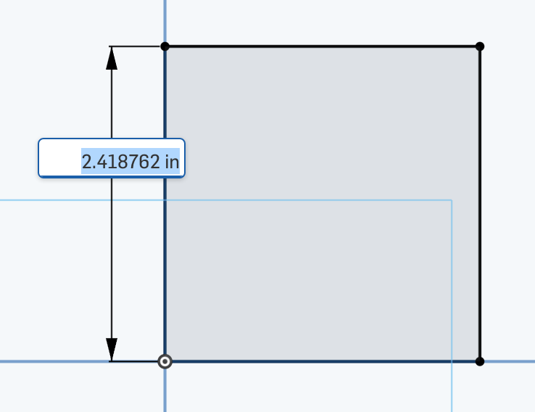

1. Type in “2” or “2 in” and press **enter/return**. You can always change the dimensions later by double-clicking on the number.

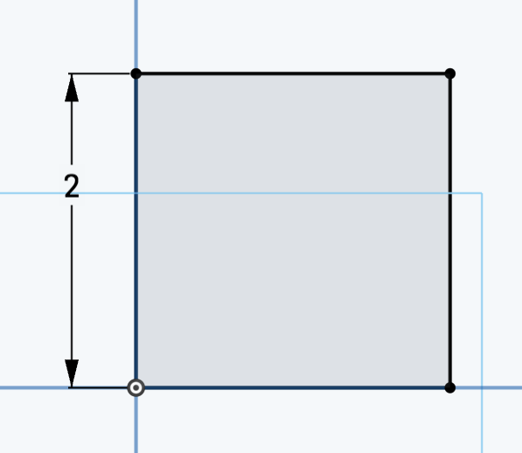

1. Now you won’t be able to drag anything in the sketch. Note that the square has turned from blue to black. You’ve drawn a **Fully Defined** square. That means that there are enough dimensions and constraints to fix all parts of the square in place.
2. Draw the circle next to the square. Click on the circle and the right edge of the square and select the **Tangent** constraint .

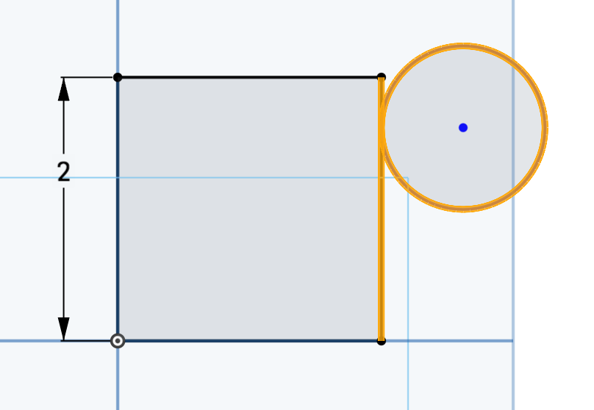

1. Now you’ll only be able to drag the circle up and down along the edge (and change the size of the circle). Note that the square does not move this whole time:

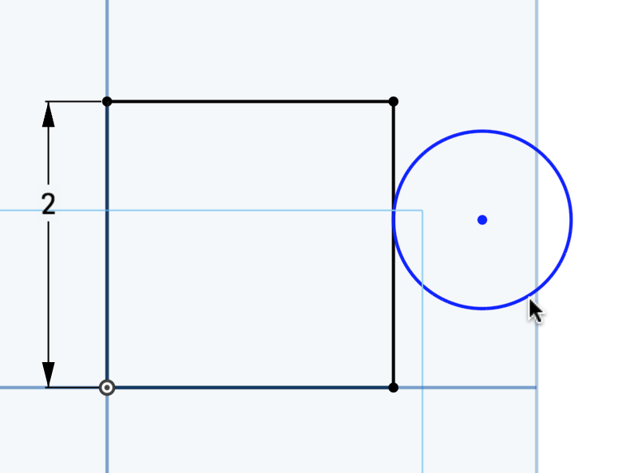

1. What if you wanted the center of the circle to be in line with the top edge? Select the center of the circle and the top right corner of the square, and click on the Horizontal constraint . Now the two are horizontally aligned:

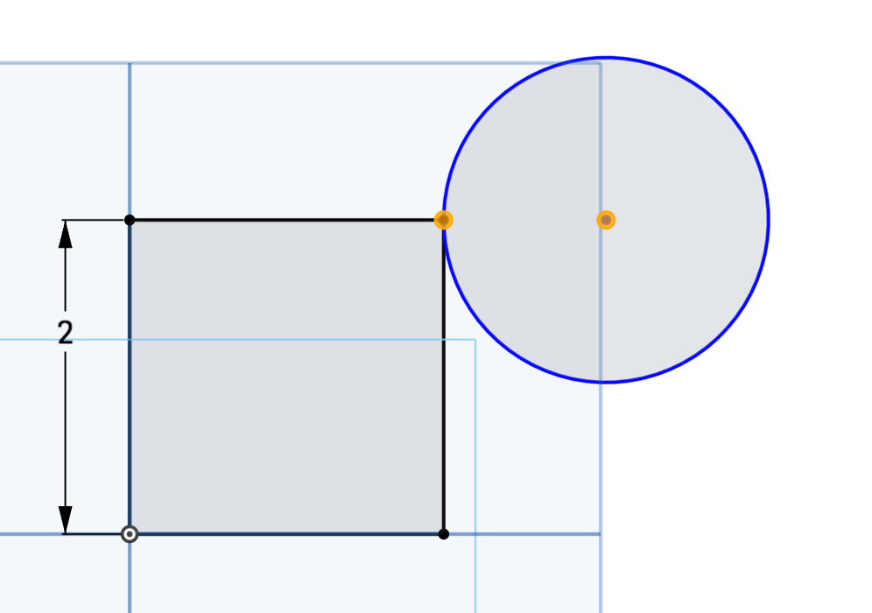

*Pro Tip: Note that your circle may not have drastically changed in size like in the picture above. The size of the circle only changes to satisfy the Horizontal constraint (as well as the other constraints we have applied so far), so your circle may look bigger/smaller than ours.*

1. Dimension the circle to have a diameter of 1in by clicking on its circumference. Now everything in the sketch is fixed:

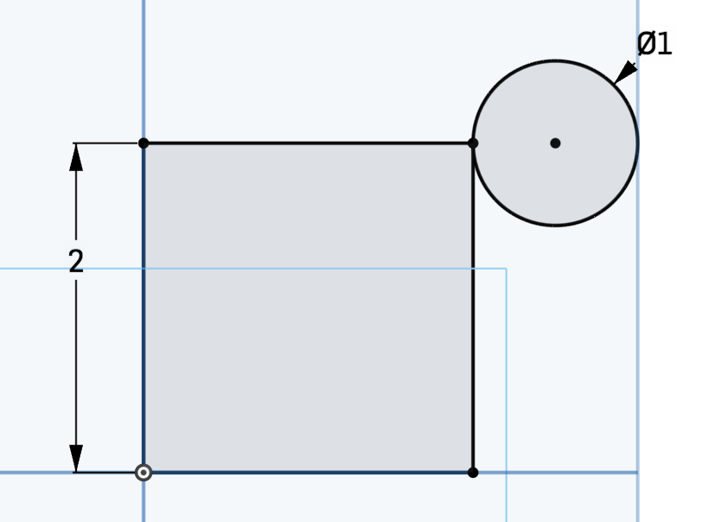

*Pro Tip: The zero with a slash across it**symbolizes that the number that follows it is the diameter (as opposed to the radius**). In this case, the circle has a diameter of 1”.*

1. Let’s review the constraints we’ve added by clicking on the “Show constraints” radio button in the sketch dialog box.

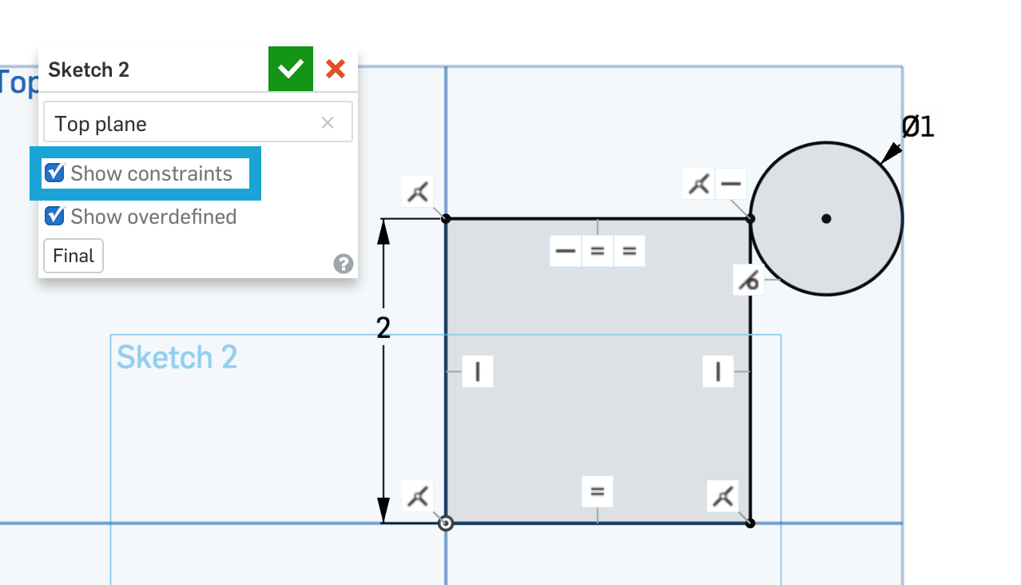

1. Notice that most of these constraints we applied manually. Hover over any of the constraint icons and Onshape will highlight the sketch entities that have been constrained. For example, if you highlight the Coincident constraint in the top left, the top and left edges will be highlighted, because their ends are coincident:

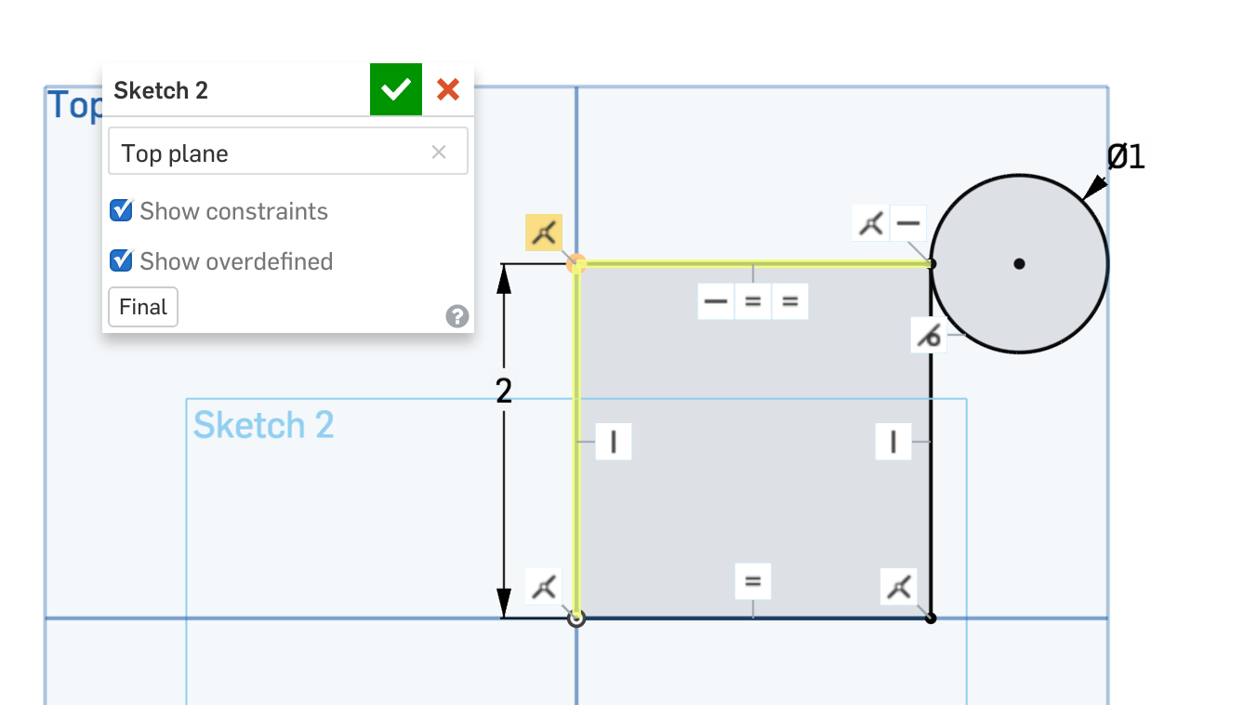

You can also select any of these constraints and delete them using the **delete** key.

## Construction Lines

Now you need to draw a square inside the square you previously drew. How would you find the center of the square?

In order to solve the problem, think about how you would find the center of a rectangular piece of paper without any measuring tools. Some people might fold the paper into smaller rectangles twice and others might fold the paper along both diagonals. Then you might open it up and point to where the intersection of the creases are.

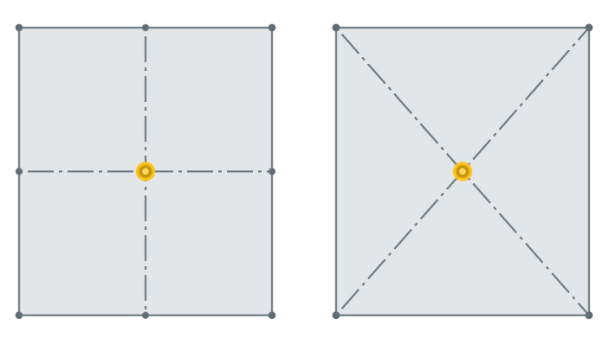

You made these creases not because you wanted to fold the paper, but because you wanted to see where the creases intersect. These creases will probably be ignored once we know where the center is, but were nevertheless important in finding the center in the first place.

The creases are analogous to **Construction Lines** in Onshape: lines in a sketch that are ignored when the sketch region is used for features, but are very helpful in finding midpoints, adding dimensions, defining the mirror line, etc. Let’s get back to our sketch:

1. Let’s draw a construction line. Click on the Line tool and the Construction tool :



*Pro Tip: You can also make a drawn line a construction line by selecting it, right-clicking, and choosing “Construction” or by pressing “Q” as a keyboard shortcut.*

1. Hover along the top edge of the square. When you reach the midpoint of the line, the edge will look like this:

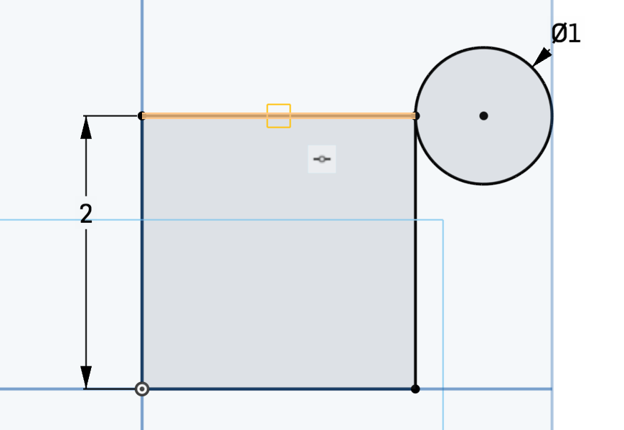

1. Click on the midpoint. Drag the construction line vertically down until you hit the bottom edge. Click on the bottom edge:

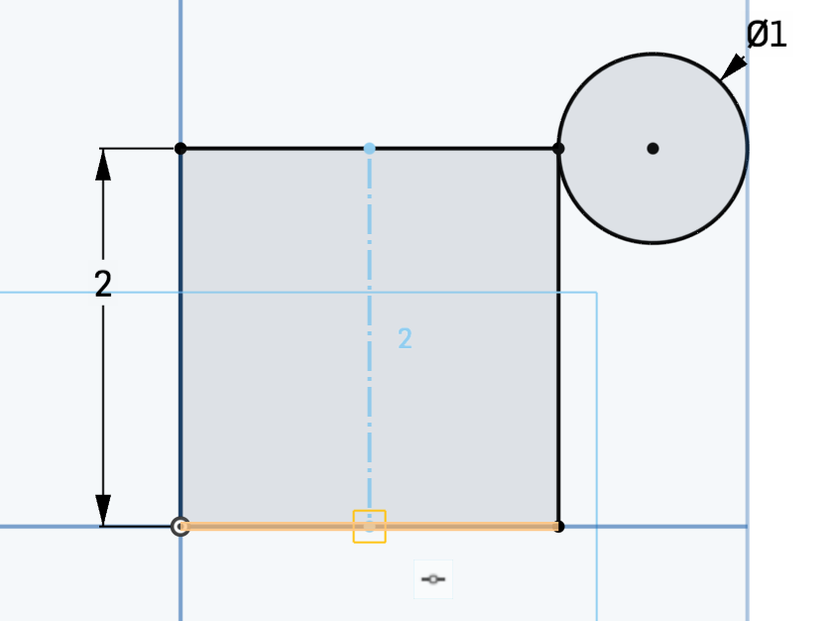

1. Now click on “Center point rectangle”. Hover along the construction line until you snap to the midpoint. Click and drag away from the point to draw your rectangle.

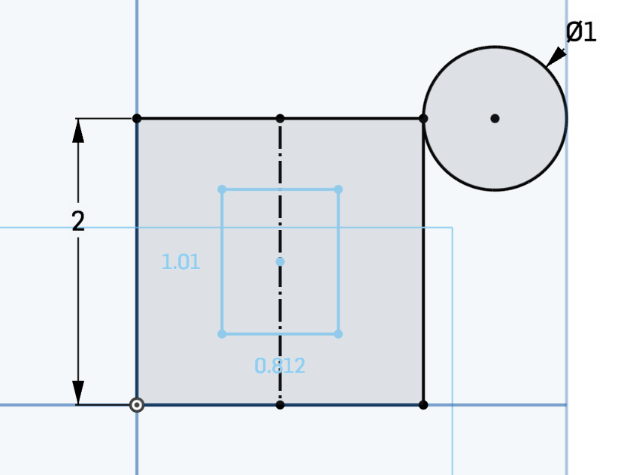

*Pro Tip: Note that when you draw your center point rectangle, Onshape applies certain constraints, such as the Horizontal and Coincident constraints you applied earlier in your original square (using these predefined shapes will save you a lot of time). This is what it should look like when you check off “Show constraints”:*

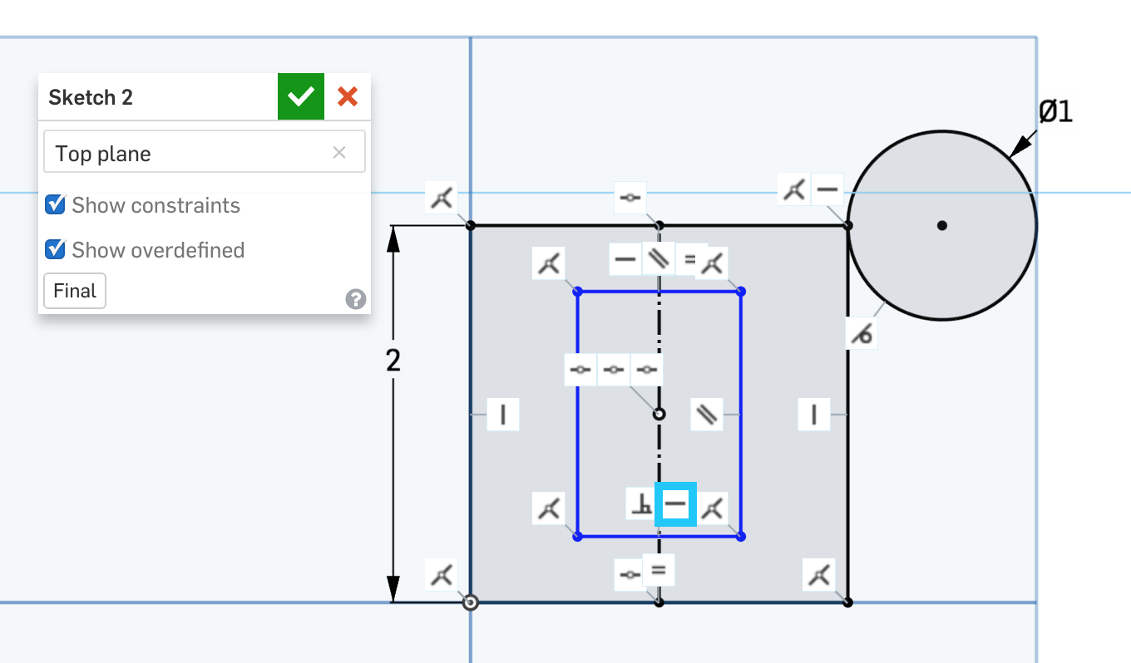

*When you drag the corners of your newly drawn rectangle, it only changes in height and width. If you click on the Horizontal constraint boxed in blue in the picture above and press* ***delete****, you can drag your rectangle by a corner so that it starts rotating:*

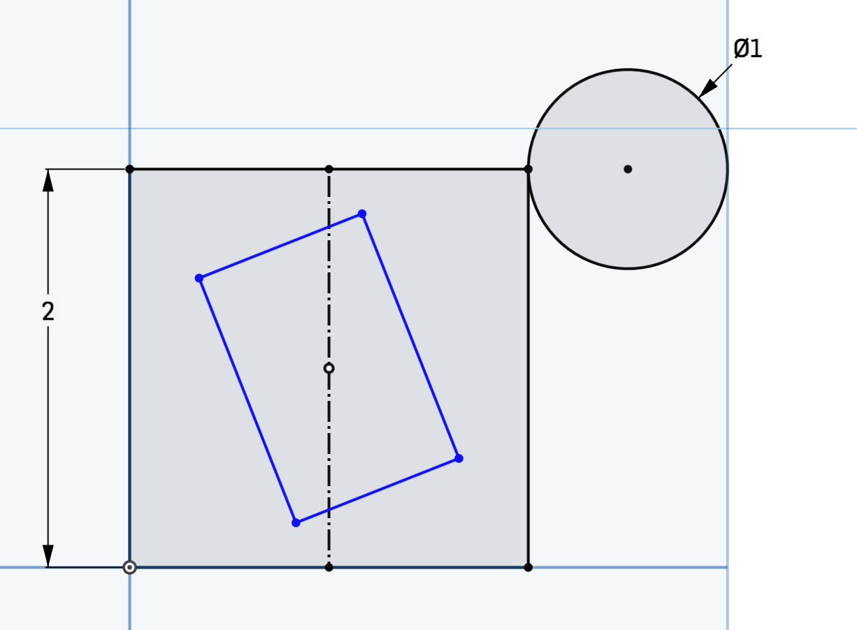

1. Undo so that your rectangle is rightside up again. Constrain the rectangle to be a square by applying the Equal constraint on the four edges.

*Pro Tip: Because of the Coincident constraints that are already applied to your rectangle, you actually only need to constrain two sides of the rectangle to be Equal when creating your square. This will still fully define the sketch.*

1. Set the distance between the squares to be 0.5”. Your sketch should end up like this:

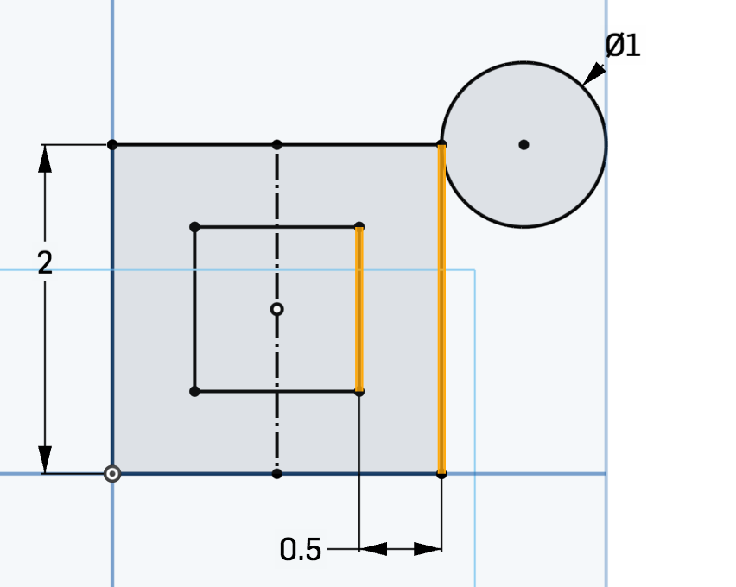

# Over-Defined Sketches

Before continuing on, let’s take a look at some possible errors that you might have encountered while drawing your sketch.

## Over-Dimensioned Sketches

If you try to dimension a sketch entity that is already fully defined, it will turn gray and will be a **Driven Dimension** (as opposed to a **Driving Dimension).** Driven dimensions can still be useful because you may want to know the dimension of that line at a glance. Dimensions turn gray when they are fixed because of some constraint. This implies that your sketch is over-dimensioned. For example, after applying the Equal constraint, you tried to dimension the bottom horizontal line like below:

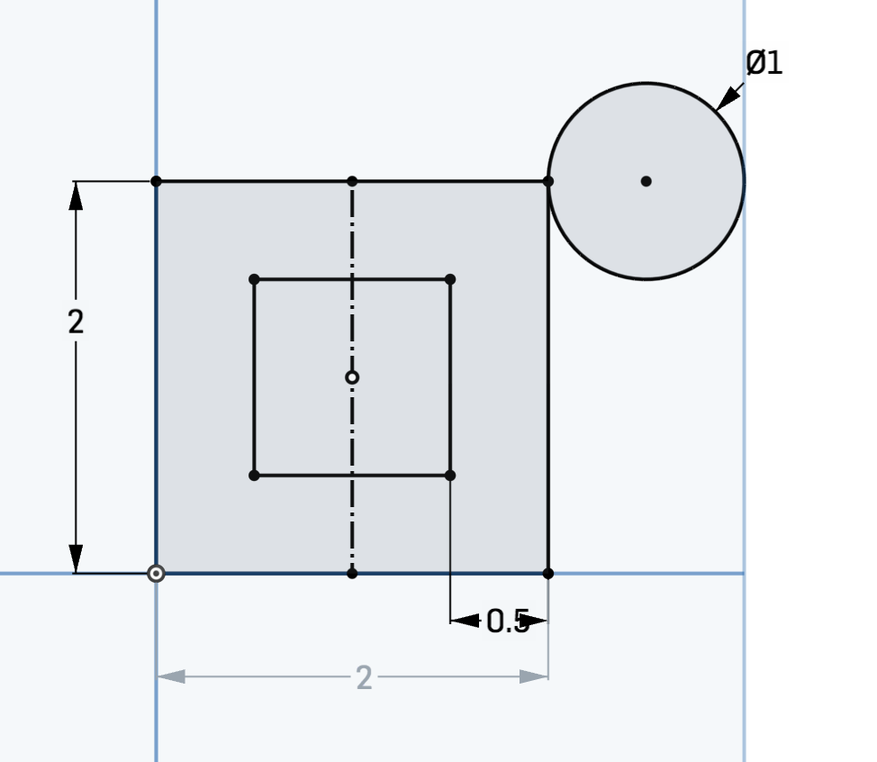

This isn’t exactly an error, but the gray dimension tells you that it’s not really necessary to apply the dimension there. Notice that even when you double-click, the gray dimension cannot be changed. You can always change a driven dimension to a driving dimension by right clicking it and selecting “Change to driving dimension”. However, this is likely to over-define and break your sketch if you are not careful.

## Over-Constrained Sketches

While it’s good to have as many constraints as necessary in your sketches, you might accidentally apply an impossible constraint that contradicts existing constraints and make the sketch invalid. Just like Onshape notifies you that a sketch isn’t fully defined by making it blue, it also notifies you that a sketch is **Over-Defined** by making it red and giving the message “Sketch could not be solved”.

For example, if we tried to apply the Parallel constraint  instead of the Equal constraint on the top and left edges of our square, our sketch will look like this:

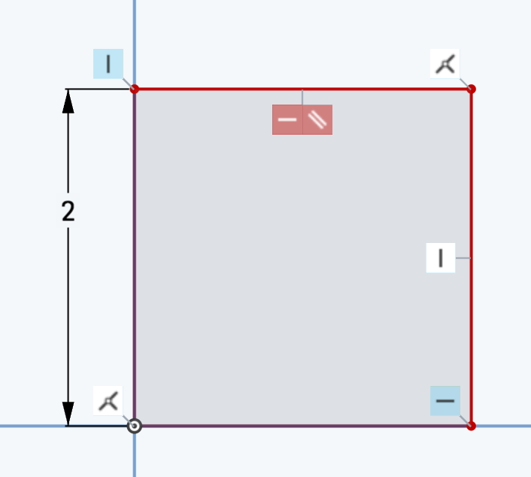

Onshape highlights the part of the sketch that couldn’t be solved to make it easier for us to know what’s wrong. Since it’s impossible for a vertical line to be parallel to a horizontal line, go ahead and delete the red Parallel icon.

# Dimensions & Constraints in 3D Objects

In the beginning of this lesson, we introduced **Design Intent** and explained that it was the practice of clearly defining your object’s requirements. Now that we’ve looked at dimensions and constraints in 2D sketches, let’s go back to our clock.

We can now guess how each design requirements can be satisfied with some dimensions and constraints in the sketches that make up the clock:

1. *The hands should always be located in the center of the clock, no matter how short the hands may be.*

If you look at the sketch that makes the minute hand, you notice that the two of the dimensions measure from the origin (highlighted below). No matter how long or short the hand is, it still rotates about the center of the clock:

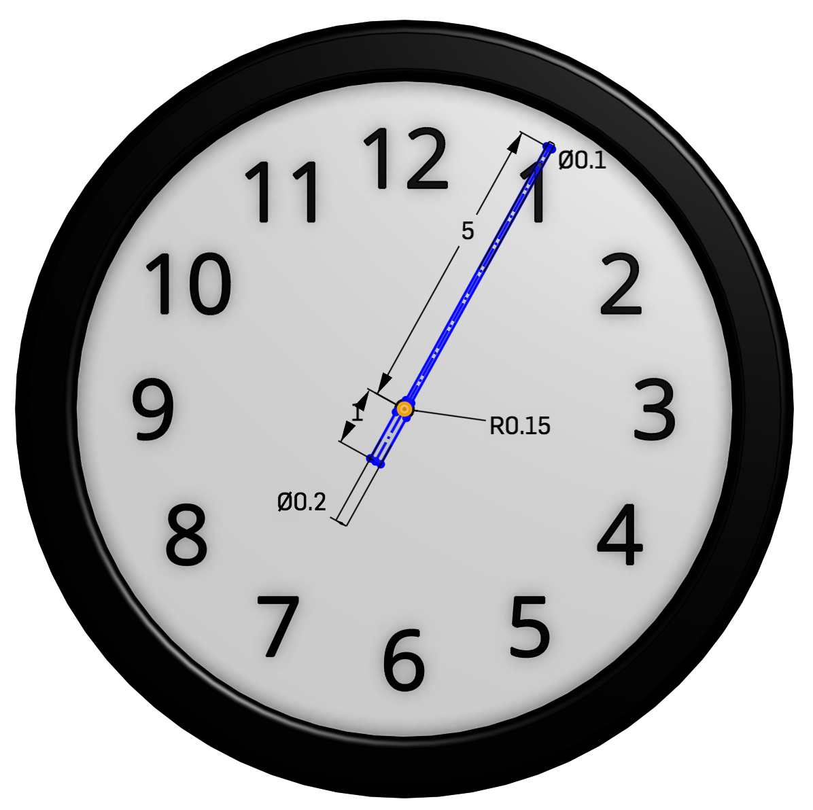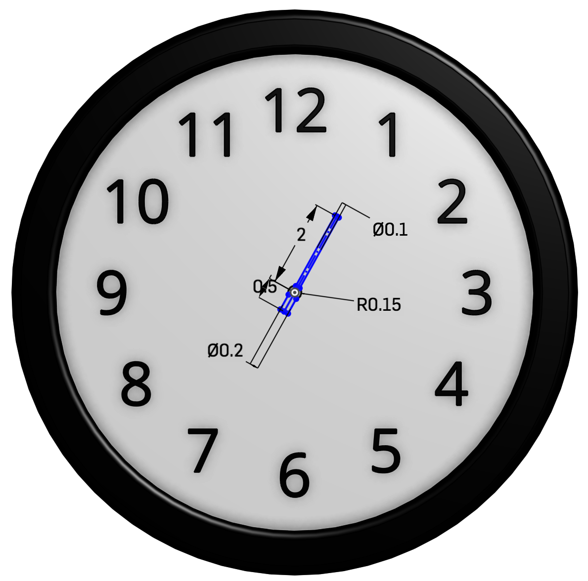

1. *The numbers should always be equidistant from the center of the clock face, so if I move one of the numbers closer to the center, all the numbers should move closer.*

The Equal constraint was added to constructions lines in the sketch below, so if you change 4.2” to 3”, all the numbers will move inward.

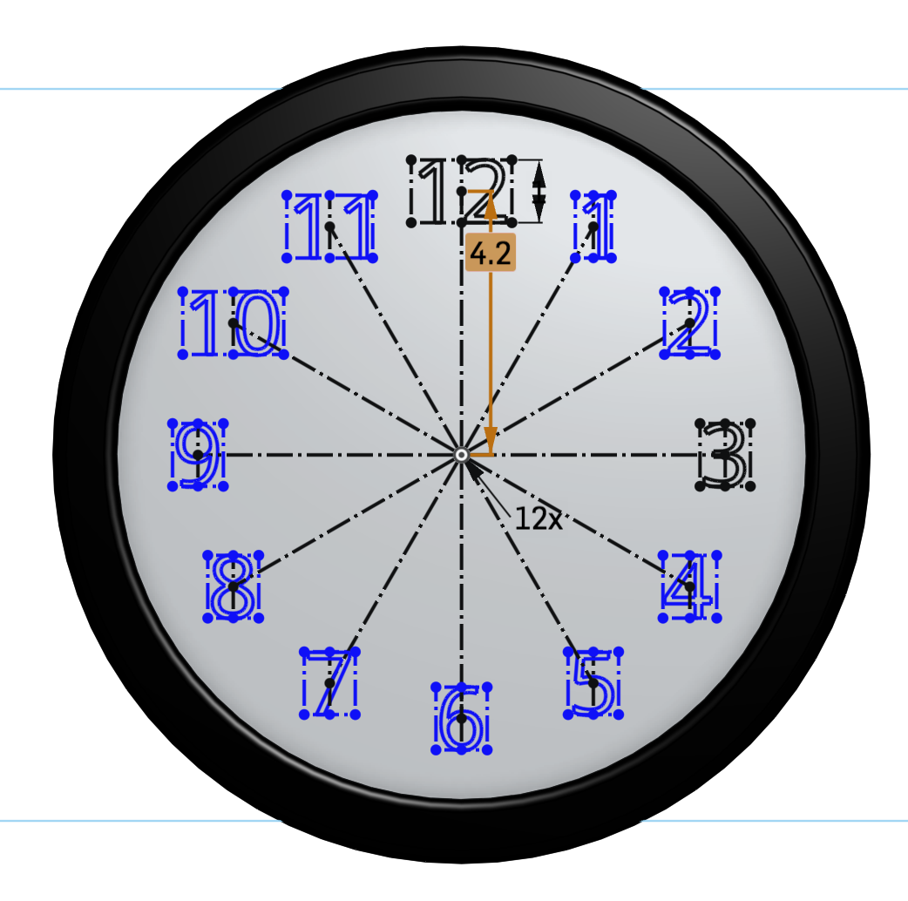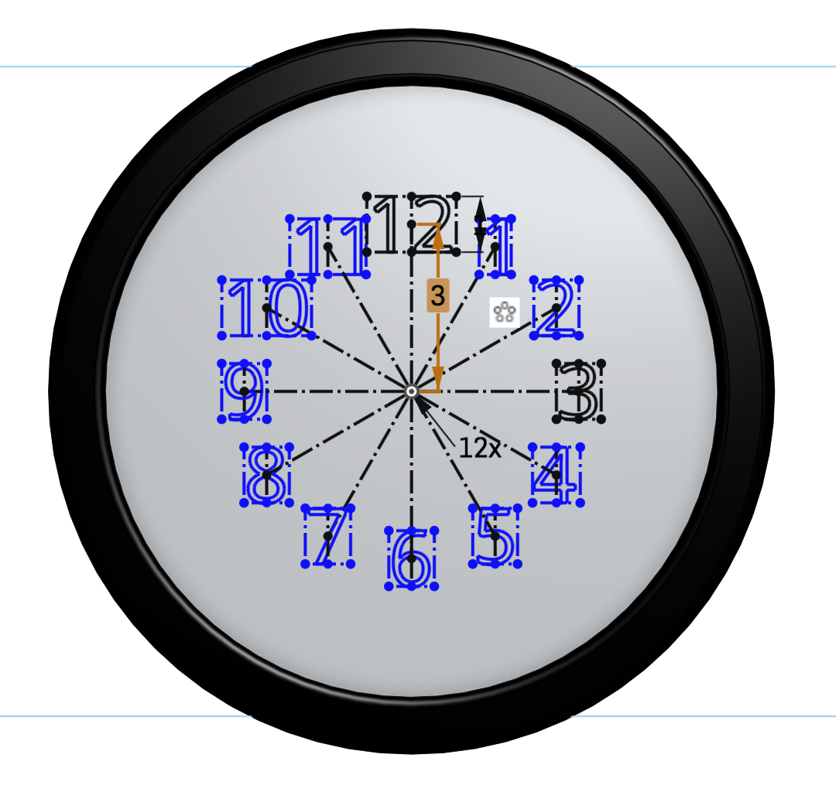

1. *The numbers should always have the same height, so if I make one of the numbers bigger, the rest of the numbers should also become bigger.*

The Equal constraint was also added to the heights of all the numbers, so if you increase the height of one number from 1” to 1.5”, all the numbers will become bigger.

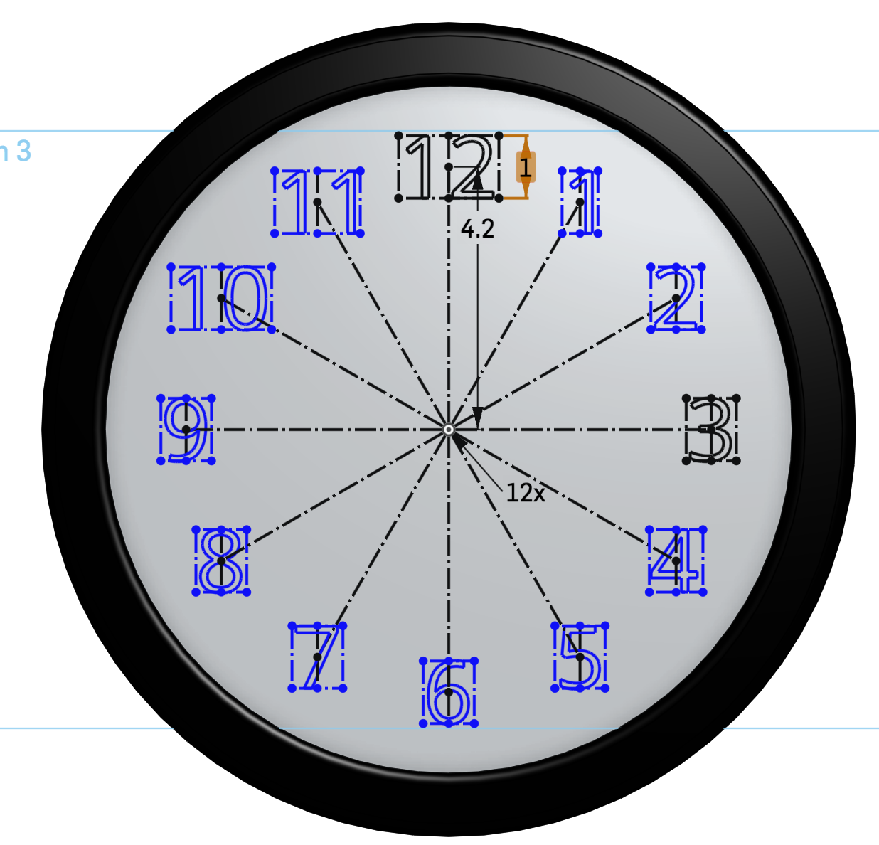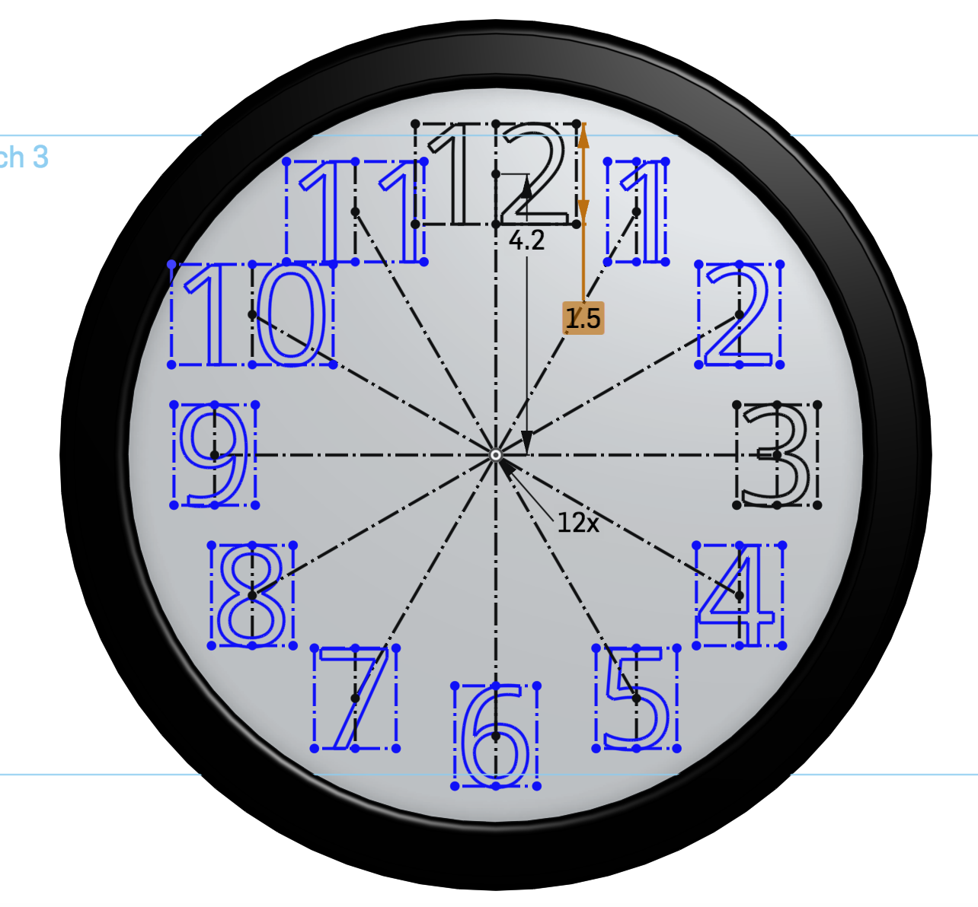

We can see from this example that you can translate the design requirements into dimensions and constraints defined by the sketches that make the 3D model. Without proper dimensions, objects may not be able to perform their functions. And without constraints, you might get unwanted changes in features when you change these dimensions or move the reference geometry. Part of design intent is thinking about what kind of dimensions and constraints are meaningful and necessary in creating your part. Note too that these dimensions and constraints make it easy for me to go back and make changes to my clock. If I want to change the height of the numbers, I just have to change one dimension (from 1 to 1.5) instead of twelve individual ones.

## 

## Units

Now that we are about to start putting real numbers (in the form of dimensions) into our designs, it is important to think about our units. They can be changed at any time during our design, but it is smart to think about it before we start designing. [Appendix B in Week 1](https://docs.google.com/document/d/18TqXfFnc84yUH8kGFHzOAub3qRCUsnNdW0BrJDDD0RQ/edit#heading=h.itrlfn44nutg) discussed how to set the default units but sometimes a specific project needs to be in different units. To change the units for the whole document, just pull down the menu in the top-left corner of the screen, and select “Workspace units…”, make the desired changes, and click the green check mark:

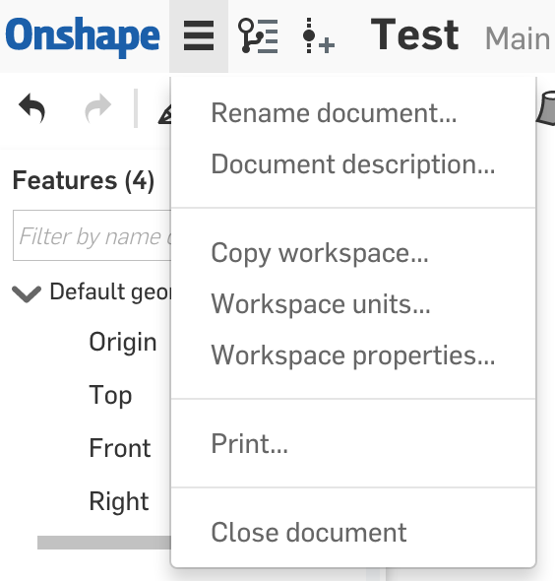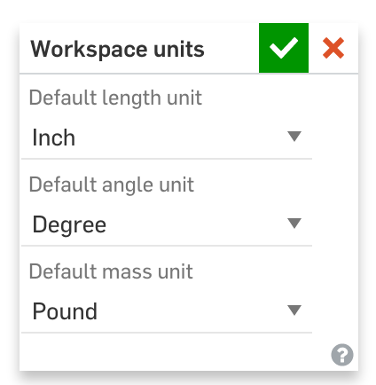

It is quite common nowadays for products to have a combination of parts that are made in different parts of the world. As a result, it is quite common to have a mixture of parts that are both in inches and in metric.

# Making an Accurate Part

Now let’s make the following 3D model:

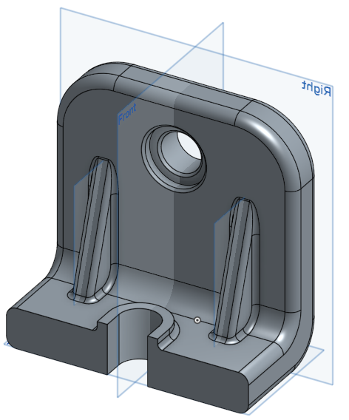

You may not know how to do some of the features shown here, or even what this part does (you will soon!), but let’s think about what the design intent is. Three design requirements might be:

1. The thickness of the part should be uniform.
2. The holes on the Right plane should always be in the middle, no matter how big the part is.
3. The two triangular ribs should be placed symmetrically across the Front plane.

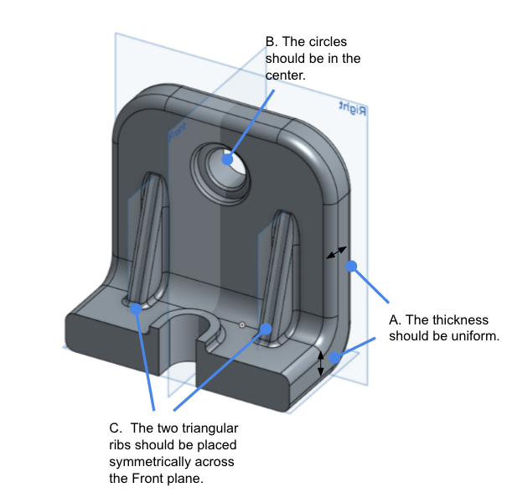

Let’s begin designing this part, exploring how we can satisfy the design requirements using dimensions and constraints:

1. Start by creating a new document, name it “Week 2 - Design Intent”, and creating a sketch on the Front Plane. Sketch an “L” shape on the Front Plane, with the outer corner on the origin as shown. This will be the side view of our part (as if we were looking at it so that it looked like an “L”).

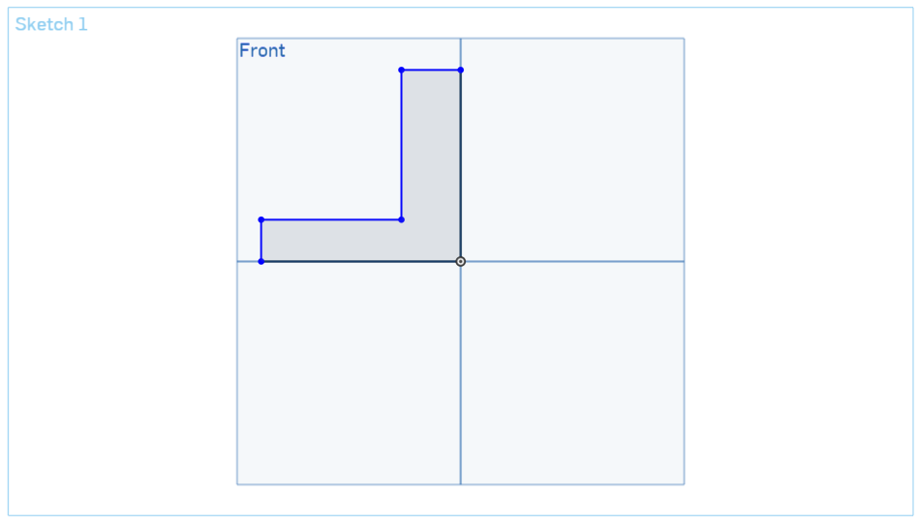

1. Let’s add some dimensions to our sketch by clicking on the dimension  tool. Dimension the “L” like below:

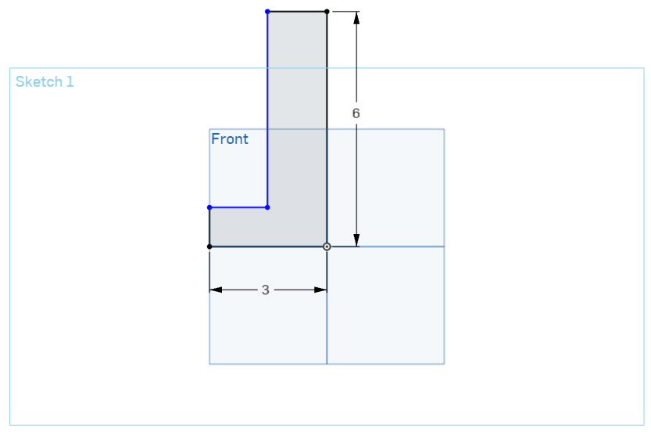

1. Now, we want to make the thickness of both legs 1 in. Instead of creating two “1 in” dimensions, we are going to put in “design intent” by creating an equals constraint. Click the two short edges of the “L” and click on the equal  icon. This constraint dictates that the edges will always have equal length, no matter what (satisfies Design Requirement A):

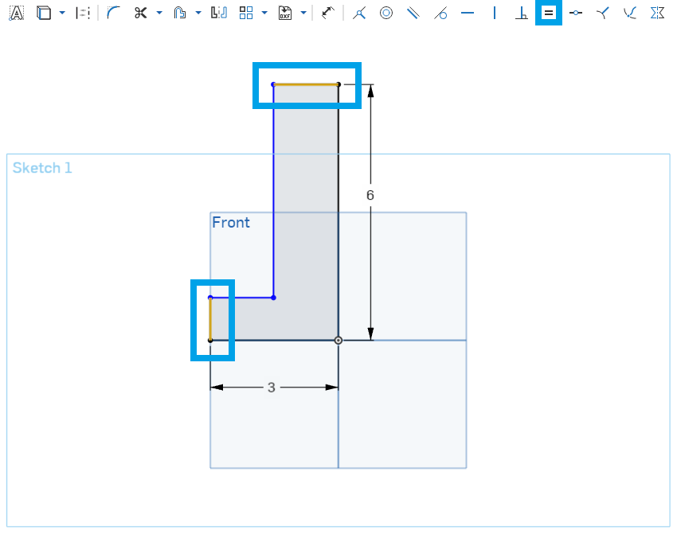

1. Now, both of the legs are the same length, and we can create a single “1 in” dimension:

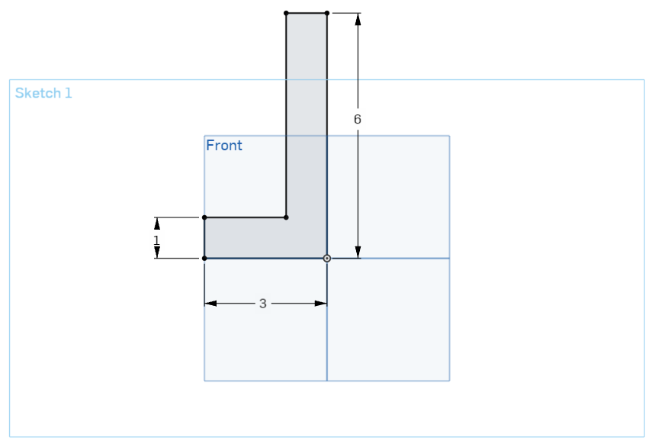

*Pro Tip: If you double-click on the dimension you just created and change it from 1” to 2”, the top edge will also change to 2” because the edges are constrained to be equal.*

1. Let’s review the constraints by clicking on the “Show constraints” radio button in the sketch dialog box.

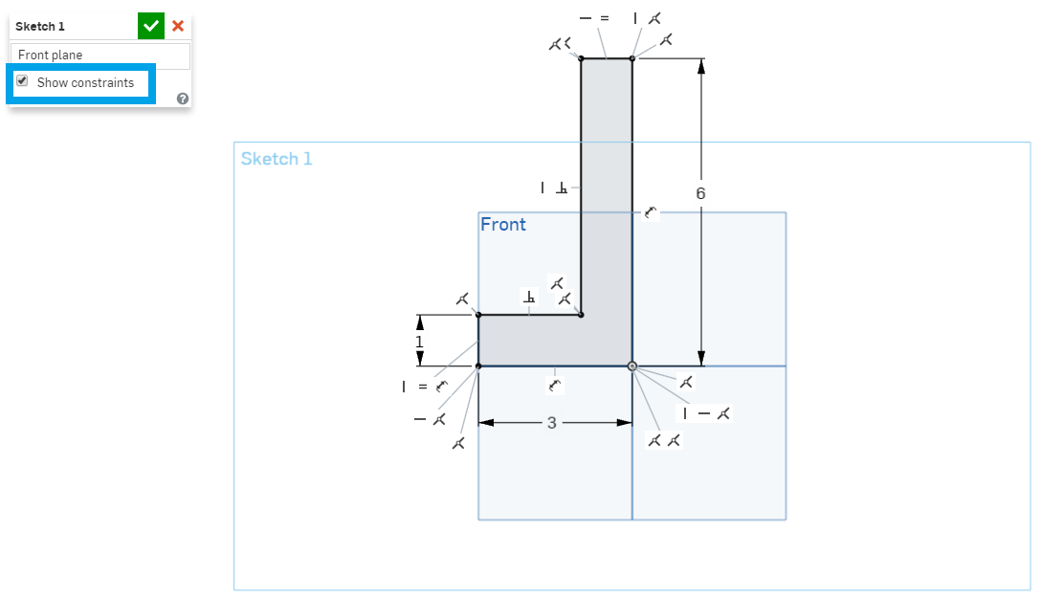

1. We mentioned earlier that you can only drag and move a sketch entity when it’s blue. When it turns black, you know that it’s **Fully Defined**. This is important, because a fully defined sketch entity is more stable (it can’t be accidentally dragged), and its design intent has been fully documented. At this point, our “L” sketch should be completely black. If it isn’t, use the picture above as a guide to specifically add the constraints that are missing. More often than not, a line is not perfectly vertical or horizontal. You almost always want your sketches to be black – to be fully defined.

*Pro tip: If you have a hard figuring out what constraints you are missing to fully define your sketch, try clicking and dragging one of the blue sketch points. If it moves, you know that that sketch entity needs constraining.*

1. Remember that you can delete a constraint by clicking on it and hitting the **delete** key on the keyboard.

*Pro Tip: Sketch slowly at first. While learning to sketch in Onshape, it is important to recognize which constraints Onshape is attempting to apply by automatic inferencing (you will see an icon appear while sketching). If you are careful in your sketching, the automatic inferencing can be very helpful, and save a lot of time. If you sketch too quickly, Onshape may add the incorrect constraints, and you may spend more time correcting it, in order to get the proper design intent. If you don’t want Onshape to automatically add constraints, you can hold to* ***shift*** *key while laying down geometry.*

1. Accept the sketch.

# Extruding Options

1. Click on the extrude tool, and this time let’s pull down the end condition dropdown box (which defaults to blind) and select “Symmetric”.

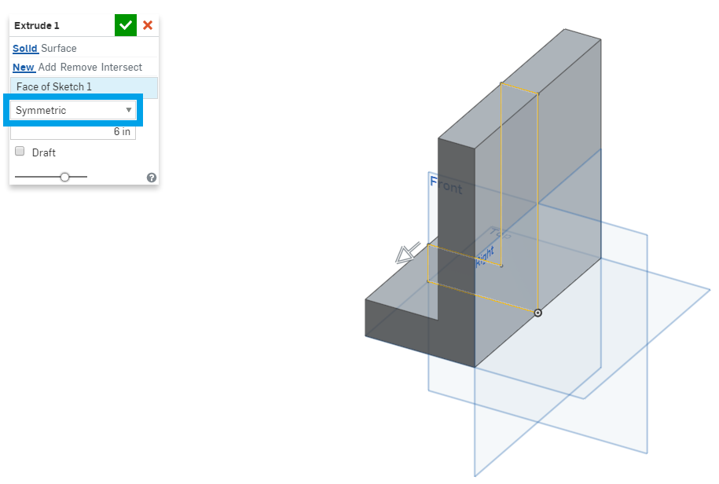

1. Extrude the “L” 6 inches deep, and accept the extrude. Notice how the “L” shape is now extruded out symmetrically from the sketch plane (3” on each side). If you had left it as blind, the L would have only been extruded in one direction.
2. Now, let’s create a sketch on the back side of the “L”, that is, the side on the Right plane.

*Pro Tip: “Pre-selecting” can save you a lot of time. In this case, pre-selecting the face you want to sketch (it will highlight orange) before clicking the Sketch button will save your mouse a round trip journey from the feature toolbar to the graphic area, and back again. It may not seem like a lot now, but when you create hundreds of parts, each with hundreds of features, that time starts to add up quickly!*

1. We’re going to draw a circle in the middle of this face, and we’re going to utilize **Automatic Inferencing** to do it. Click on the circle tool, now hover over the origin until it turns orange, now slide the mouse up to the middle of the face. Note the yellow dotted line, and the icon for “vertical”. This shows that we’ve “woken up” the origin and enabled snapping to it. Now when we click on the dotted line, the center of the circle will be vertically aligned with the origin. Sketch your circle here, and a vertical constraint will be applied (satisfies Design Requirement B).

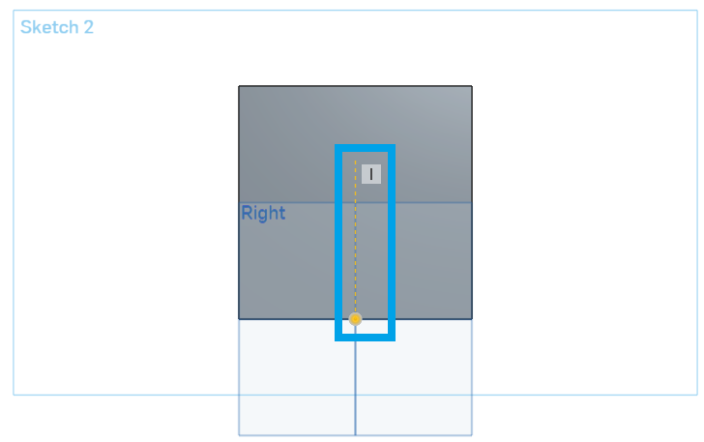

1. Add the dimensions as follows. The circle should be black, and thus the sketch is now fully defined.

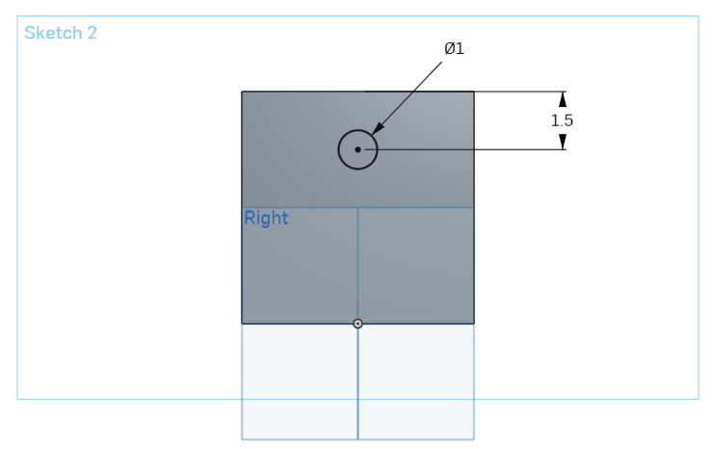

1. Accept the sketch.
2. Click on the Extrude tool, and select the circle.
3. By default, Onshape assumes you want to create a circular **Boss**, or protruding feature; however, this time we want to create a hole. By default, the Extrude dialog box has the “Add” operation selected, and we need to change it to “Remove” (Note that the direction of the extrude changes automatically as well):

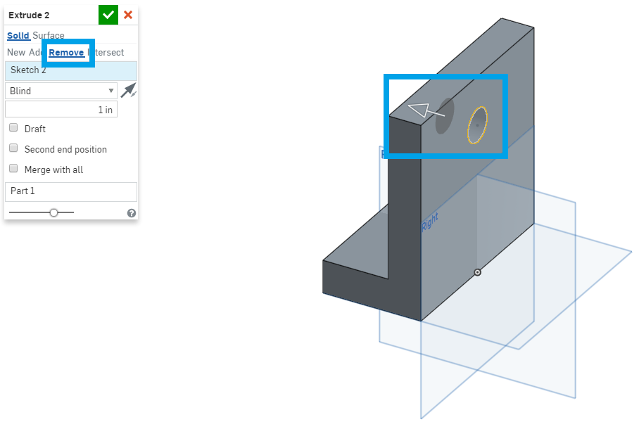

1. If we were to accept this extrude as is, we would get the geometry we wanted, but we would not have the proper design intent. This is because, right now the hole has a depth of 1”. Since the leg has a thickness of 1”, the result is a hole; however, what if the leg’s thickness was updated to 1.5” in the future? This happens more often than not. In our case, the design intent is for the hole to ALWAYS be a through-hole. Therefore, we will change the end condition of the extrude to be “Through all”. This means the extrude will always go through the entire part, no matter how thick it is.

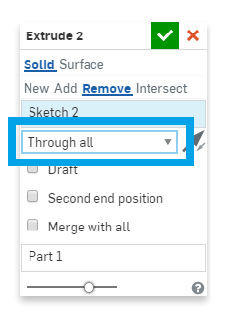

*Pro Tip: The majority of the time, the design intent for a Remove Extrude is to go through the entire part. In these cases, the depth should always be set to “Through all”. It is this consistent use of design intent and continued attention to detail that creates world-class designers and engineers.*

1. The final geometry should look like this (the reference planes have been resized to better fit the shape of our bracket):

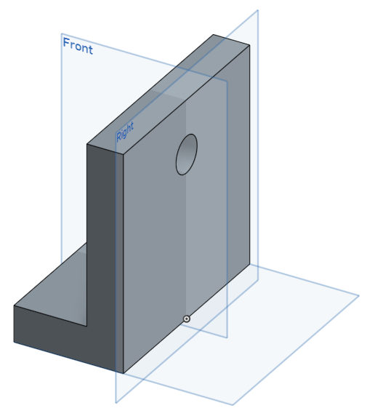

## In-Class Exercise #2:

1. Add a slot with the following dimensions and center it on the front of the “L” as shown below. Use automatic inferencing as much as possible!

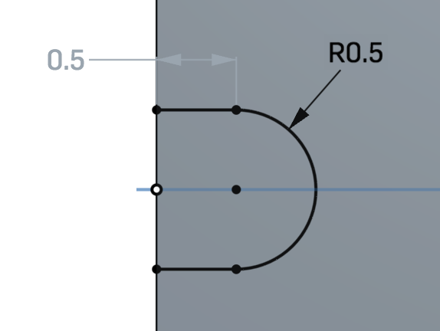 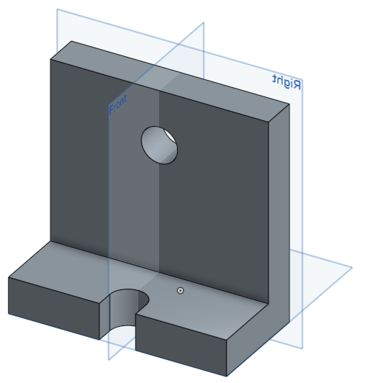

1. Add two 1.5” radius rounds to the top corners of our bracket, by sketching arcs and removing material.

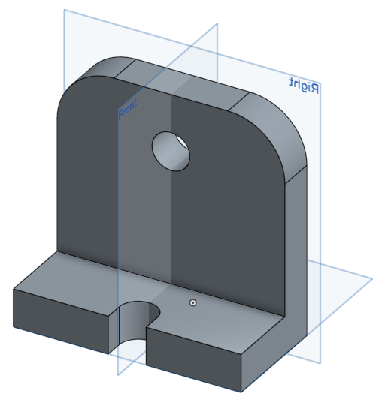

1. Add a 1.5” diameter X .25” deep counterbore to the hole:

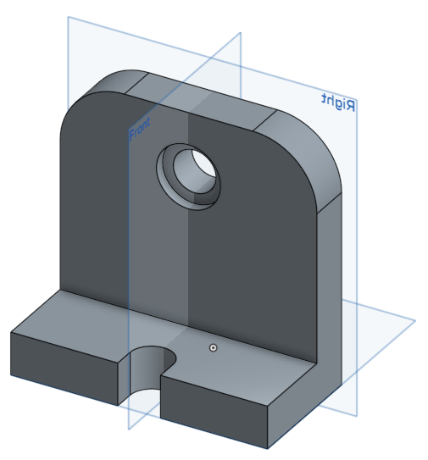

*Pro Tip: Sometimes, after geometry is created, planes and sketches are not needed (or they get in the way of selecting geometry). To temporarily hide them, just hover over them in the feature list, and click on the “eye” icon* *. This hides the plane/sketch, grays it out in the feature list, and changes the icon to a “slashed eye”* *. To unhide, repeat the same steps:*

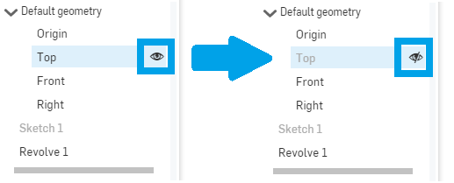

*You can also toggle between hiding and unhiding planes by pressing “p”.*

# Planes

Now that we’ve sketched geometry on the default planes and previously built geometry, what happens when we want to sketch in a location where nothing exists yet? For this we can create Reference Geometry. In this case, it’s a plane. Let’s add an off-center rib to our “L” bracket.

1. Click on the Plane  tool in the feature toolbar.
2. There are several options, which should be explored on your own, but here we will use the default option “Offset”.
3. Select the Front plane, and type in 1.75”. The dialog box should look like this:

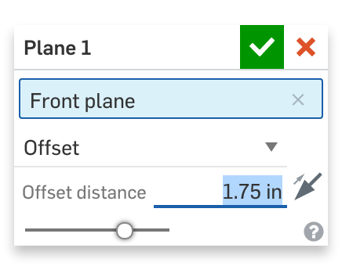

1. This should create a plane that is 1.75 inches away from the Front plane. Accept the plane with the green check mark , and it should look like this (highlighted for effect):

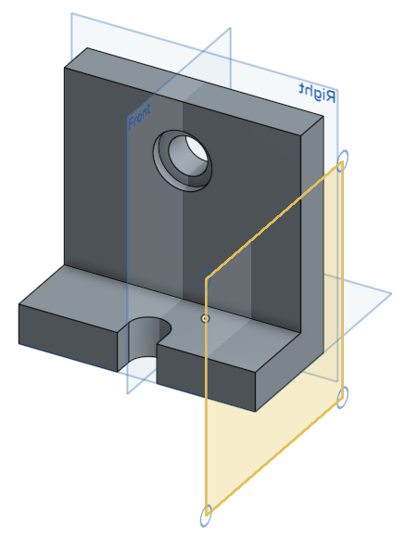

1. Now, let’s sketch a triangular rib. Click  and select the new plane.

# Projecting with the Use Tool

1. We’ll need to use a new feature called the Use Tool , which projects edges or faces of a part onto the active sketch, to complete the sketch. Click on the tool, then select the two inner edges of the “L”. The edges should project onto the new plane (reference planes hidden for clarity):

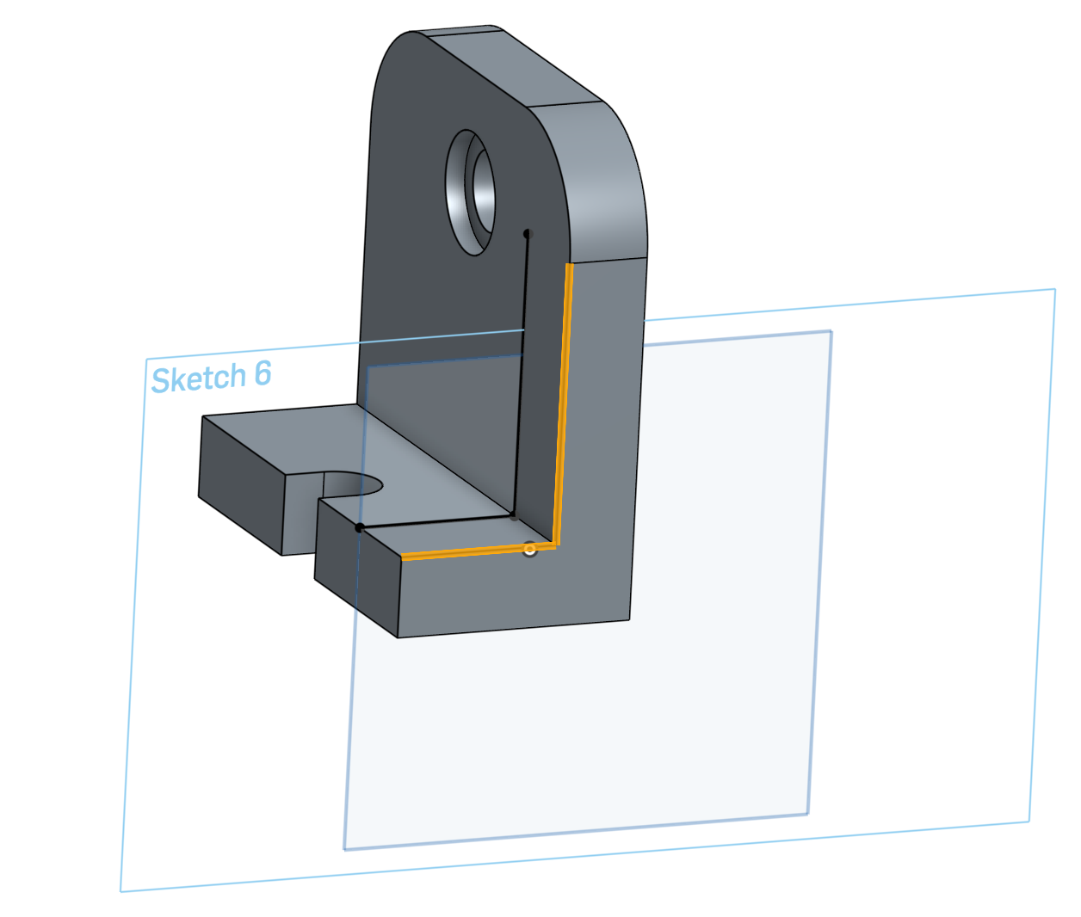

1. Use the Line 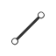 and Trim  tools to complete the sketch. Make sure the sketch is fully defined (colored black). The constraints as viewed normal to the Front plane are shown for reference:

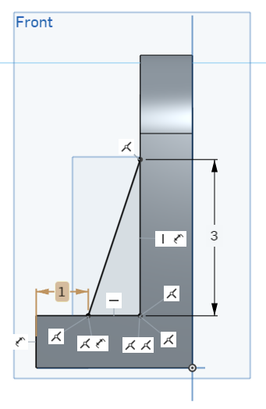

1. Accept the sketch, and extrude it ½” thick symmetrically about the plane:

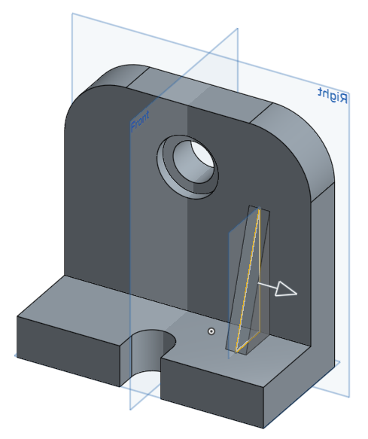

1. Now, let’s create the triangular rib on the other side of the “L” bracket (satisfies Design Requirement C). To take advantage of the symmetry, we’ll use the Mirror Tool . Click on the tool, and choose “Feature mirror” from the dropdown menu. Select the extrude made in the previous step for “Features to mirror” and Front Plane for “Mirror plane” :

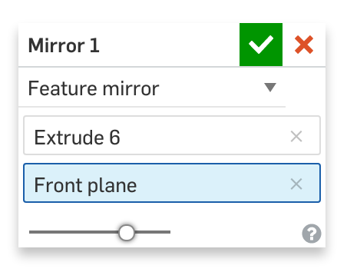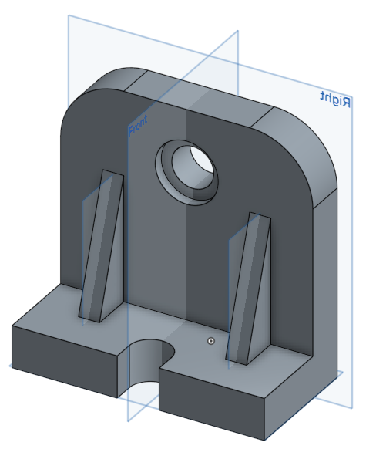

*Pro Tip: In the screenshot above, the new planes have been resized (smaller) to better fit the ribs. This is not mandatory by any means, but it is a subtle detail which keeps the model neat and tidy, and thus easier to manage as it gets more complex. You can also hide the planes altogether (keyboard shortcut = “****p****”).*

# Fillets and Chamfers

Fillets and chamfers are examples of “Feature Based Modeling”, where they don’t actually require a sketch to create geometry. Fillets round the interior or exterior of corners with a specific radius while chamfers 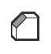create beveled (slanted) edges on selected edges or faces.

1. In this case, let’s remodel our “L” bracket from above, first by deleting the rounds we sketched in earlier:

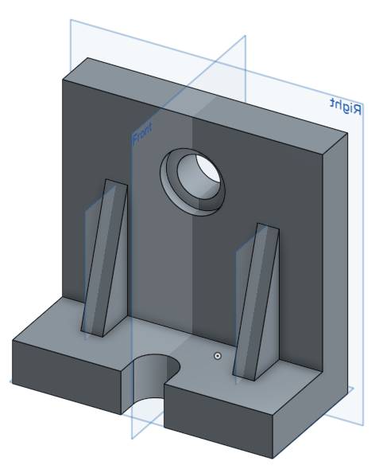

1. Select the fillet tool , and just select the edges at the top of the part (highlighted below). Type in 1.5 for “Radius”, and then the green check to accept. That’s it!

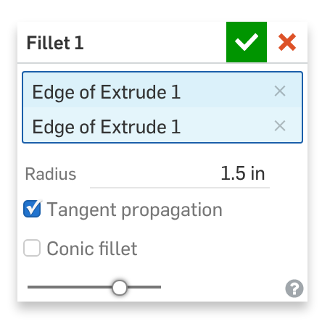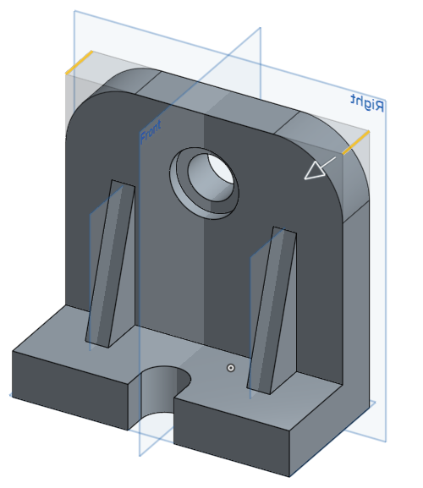

1. The chamfer tool works the same way. Let’s add a .06” chamfer to both edges of the counterbore:

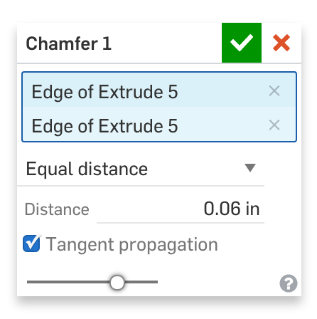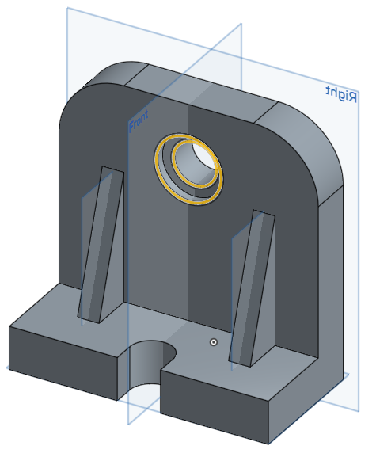

## In-Class Exercise #3:

1. Let’s add a ¼” X ¼” flange to the slot in our “L” bracket.

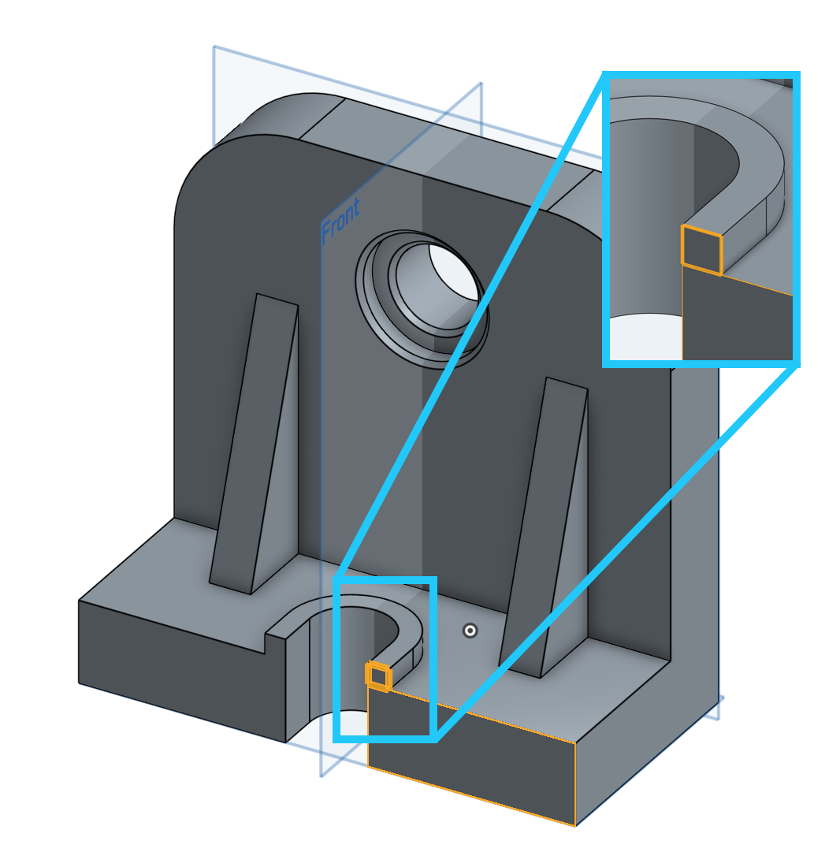

1. Finally, let’s add a few rounds to the part (The sizes aren’t important, but pay attention to which order you add them in!):



*Pro Tip: Fillets of the same size/location should be grouped together in a single feature. In this case, we have fillets of various sizes being applied to features of various sizes. In general, it is a good idea to start with the large fillets first, then create the smaller ones. It won’t always be the case, as each design is different, but it is a smart practice here. Case in point, the small radii around the ribs should be created very easily with a single feature. Doing this also makes it very easy to change the size of all common fillets at once by editing the fillet feature. This is another example of design intent.*

*Pro Tip: In our “L” bracket, we have created the fillets last (at the end of the part). This is not by accident. There are always exceptions (every design is different), but for the most part fillets and chamfers should be at the end of the part. This is because they are not part of the “core” geometry, like the ribs and holes. When building with design intent that require dimensions and constraints, radii and chamfers (and other small features for that matter) can get in the way.*

# 

## In-Class Exercise #4:

Let’s combine everything we’ve learned so far with the exercise below.

Try making a CAD model of this screw using the following dimensions. Some notes:

* Use the “Center point arc” tool (the center is coincident to the screw axis) to create the rounded edge.
* The “minus sign” (where a flat-head screwdriver would go into) is extruded from a plane (highlighted in orange in the first picture) that is offset by 0.025” from the bottom of the head.
* The bottom of the screw is chamfered by 0.05”.

Before making the CAD model, think about its design intent. How should we use the given 2D sketches? Where should the “minus sign” be located? What kind of 3D features should we use?

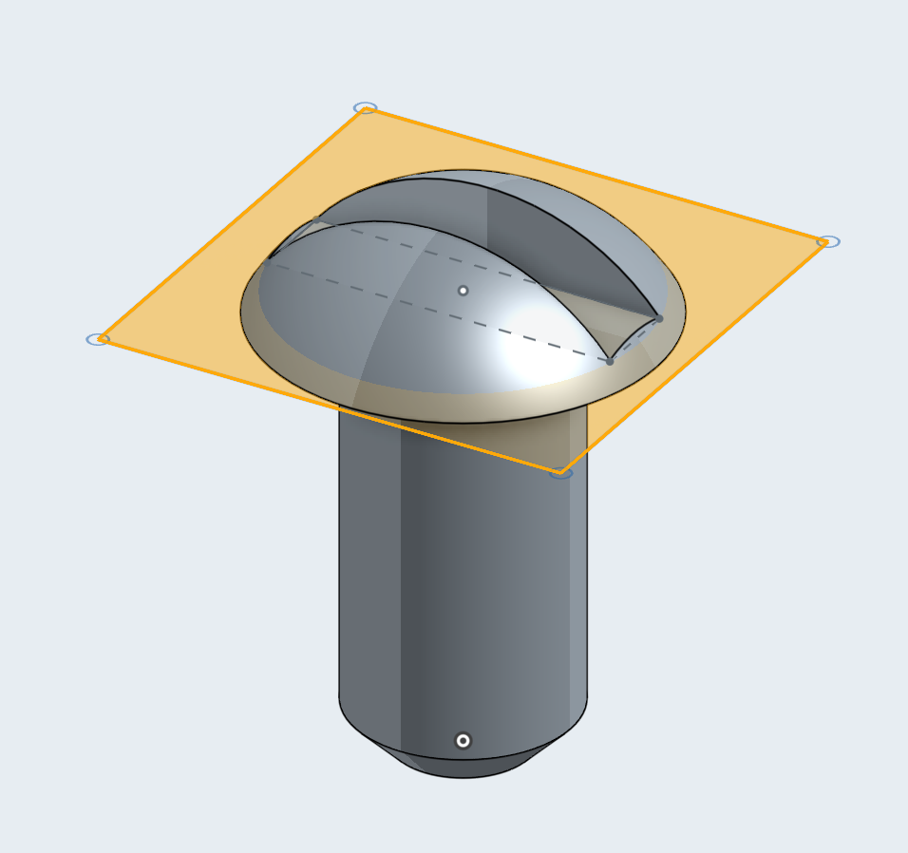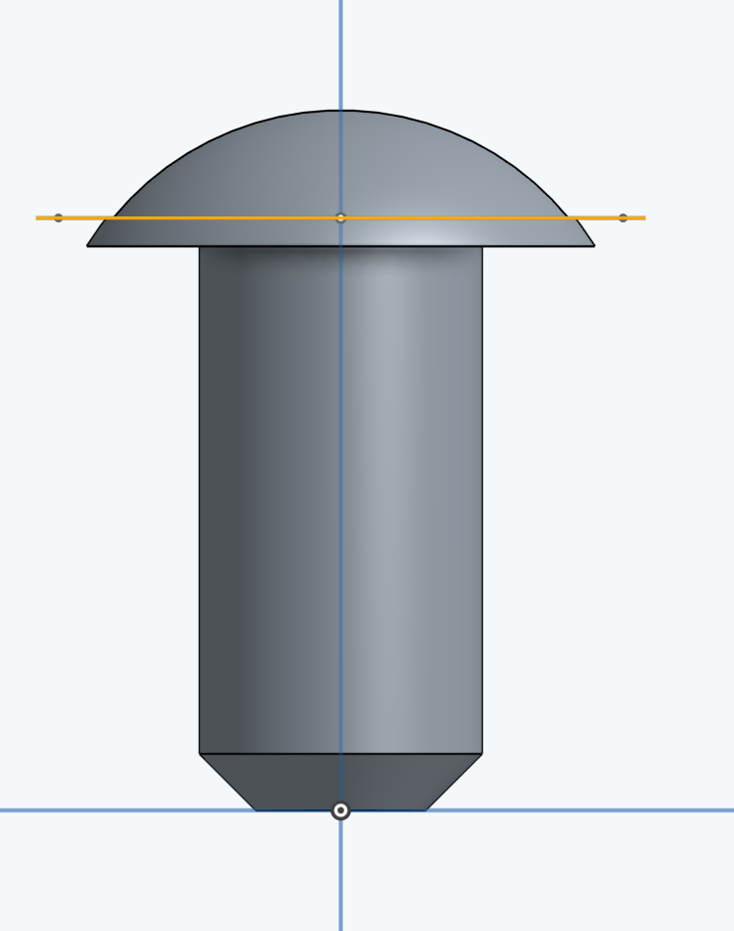

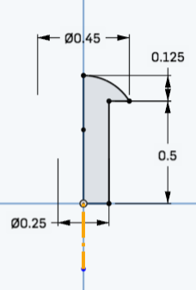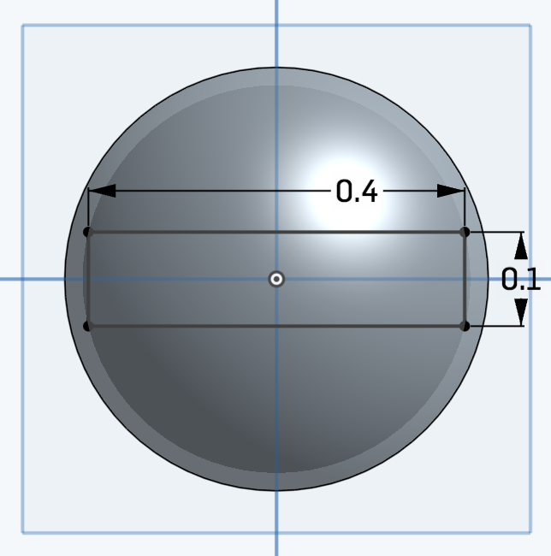

*Pro Tip: Most fully revolves shapes, like this screw, exhibit* radial symmetry *and only require you to sketch one half of the shape, because when that half is revolved, it will fill up all 360º of space. Despite this, it’s still natural to dimension in terms of diameters instead of radii. You’ll notice that in the picture on the left, we are doing just that with our 0.45 and 0.25 dimensions. You can do this too by first creating a “centerline” (the highlighted orange construction line). Then, you can use the dimension tool to click on the construction line, the entity you are dimensioning to, then moving the dimension to the other side of the construction line. Onshape will automatically infer that the construction line should be treated as a centerline, and will create a diameter dimension instead of a radius dimension.*

# Multiple Sketch Regions

A really powerful capability of Onshape (which is not found in many other CAD tools) is that it can utilize multiple sketch regions. We’ll use multiple sketch regions to make this:

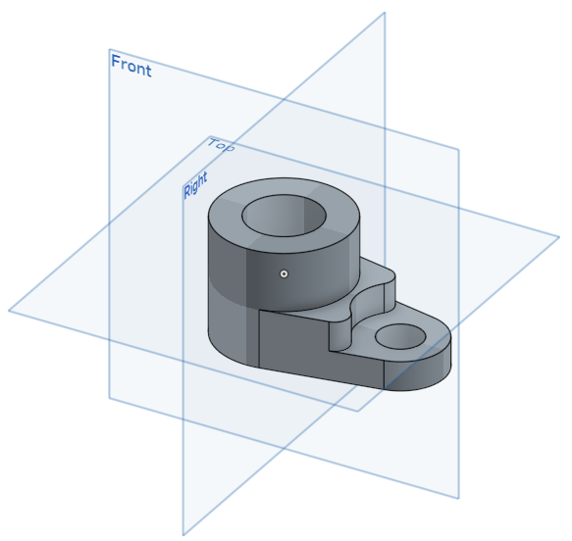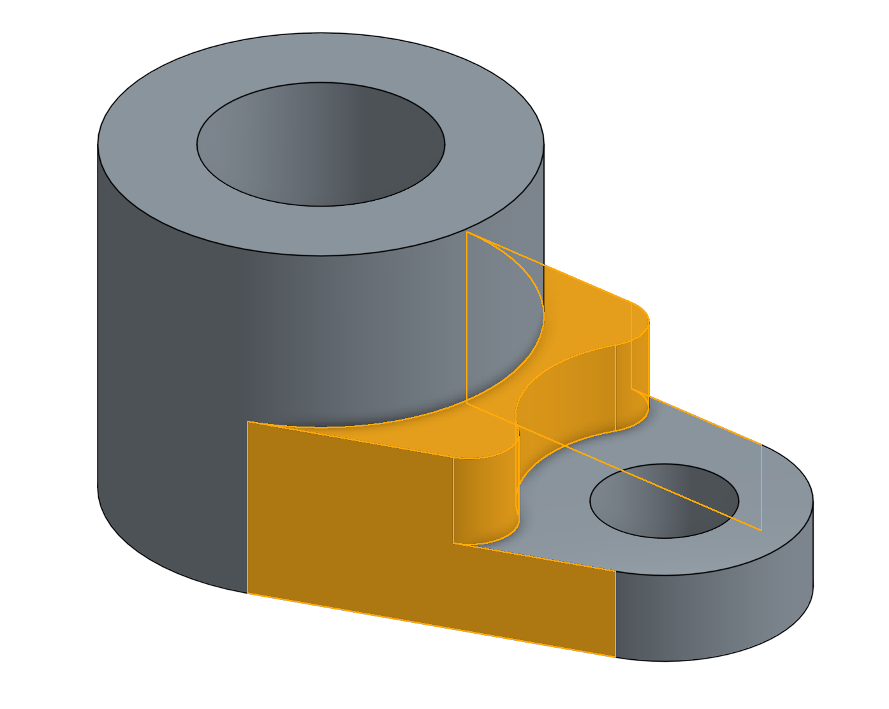

You might think that this part looks like three different parts - two hollow cylinders with a part in-between (highlighted above) - glued together. What is its design intent? Some design requirements may come to mind:

1. The two cylinders should be connected smoothly. If one of the cylinders become bigger, the part should still connect to the other cylinder smoothly.
2. The three sections of the part have three different heights in the part.
3. The part should be symmetrical across the Front plane, so if you change one side of the part, the other side should change as well. This mainly applies to the center (highlighted) area.

Let’s see how these design requirements are satisfied:

1. Let’s start by creating the following rough sketch, with multiple sketch regions. Note that this has 5 sketch regions:

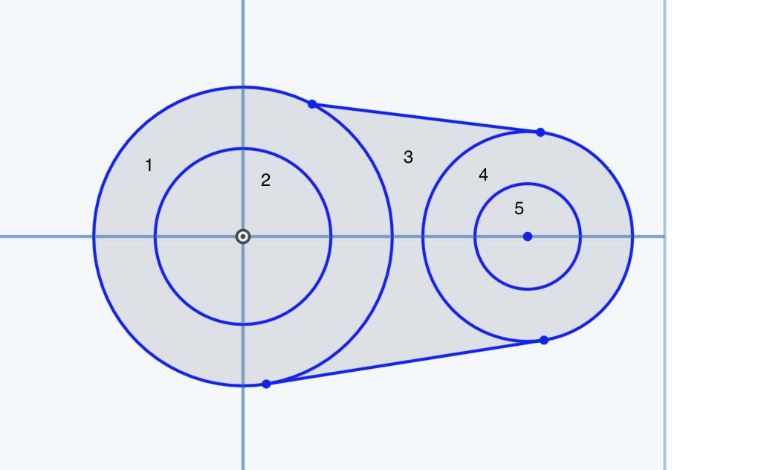

1. Constrain the top line to be tangential to the left outer circle by selecting both and clicking Tangent . If necessary, do the same for the right outer circle (satisfies Design Requirement A).

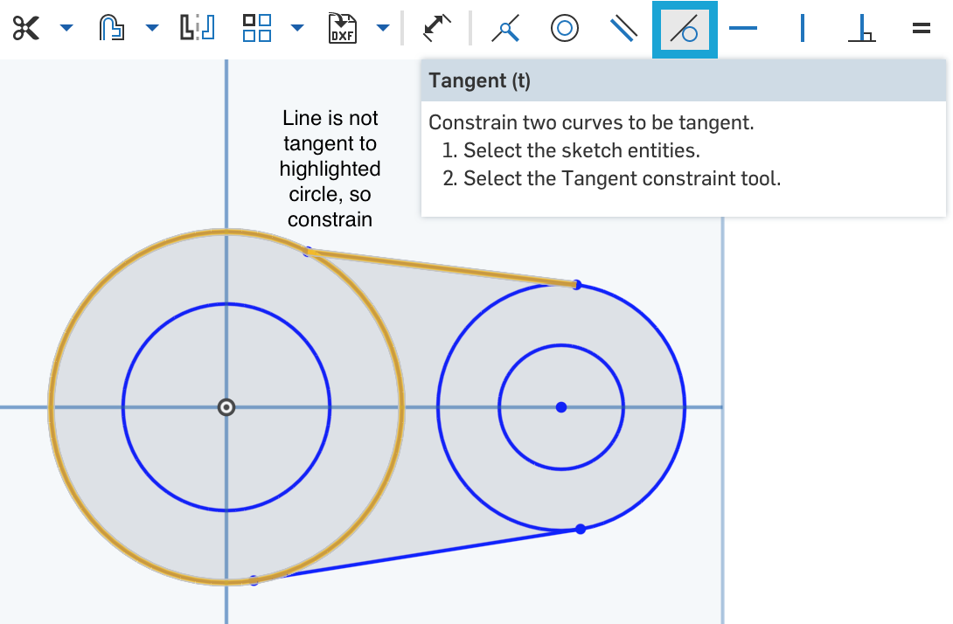

*Pro Tip: Avoid having to manually constrain both circles to the top line by using automatic inferencing. Let’s say you started your top line by making the first click somewhere on the left outer circle. Before clicking on the right outer circle to complete the line, hover along the circumference of the circle until the line becomes a highlighted dotted line. Notice that the Tangent icon*  *appears. Now the top line is tangent to the right outer circle and you wouldn’t have to do step 2 for that!*

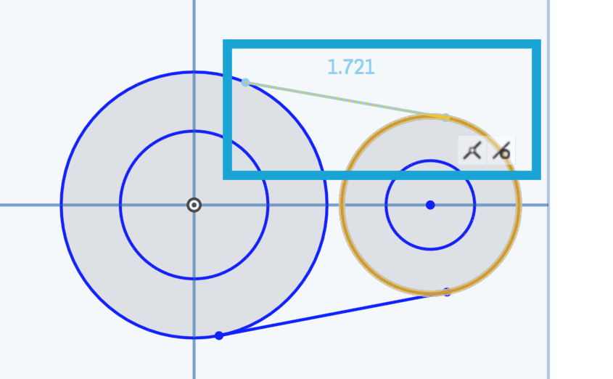

1. Repeat step 2 for the bottom line.
2. After adding the dimensions, the sketch should turn black and end up looking like this:

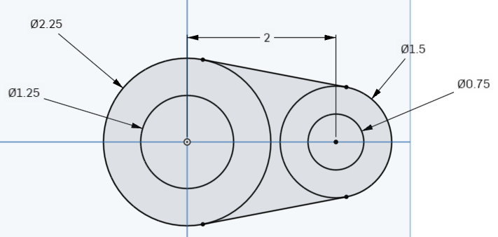

*Pro Tip: Most CAD users use this same process (getting the rough shape of the sketch => adding the constraints => adding the dimensions) to complete their sketch. Notice, when you add the first dimension, Onshape resizes the entire sketch automatically! Not all CAD tools do this, so take advantage of it! The author has spent countless hours troubleshooting sketches in other CAD software because they did not do this!*

There are two ways to make the final part, which we will refer to as method (a) and (b). Let’s start with method (a).

1. Now, let’s extrude it downwards. Select the three largest sketch regions:

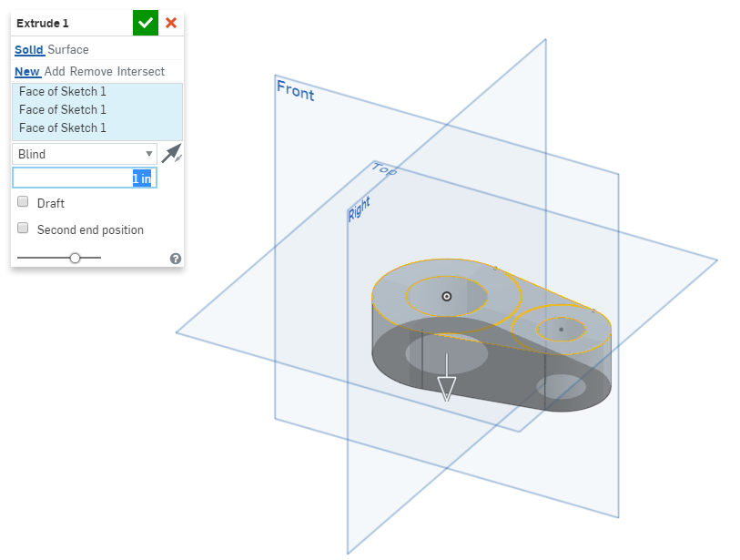

1. Note how Onshape only extrudes the specific sketch region you select.
2. Accept the extrude.
3. Now, let’s create a second extrusion using the same sketch. Onshape hides sketches after they are used by default, so we’ll need to unhide the sketch. Hover over it in the feature list, and click the “slashed eye” icon , just like we did before (here it is highlighted orange for reference):

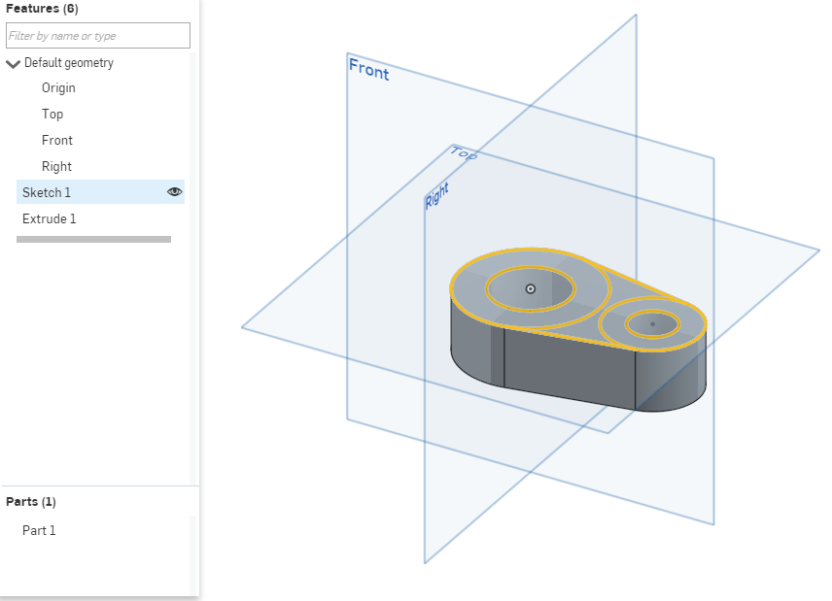

1. Now click on the extrude tool, and extrude the large circle upwards 1”.

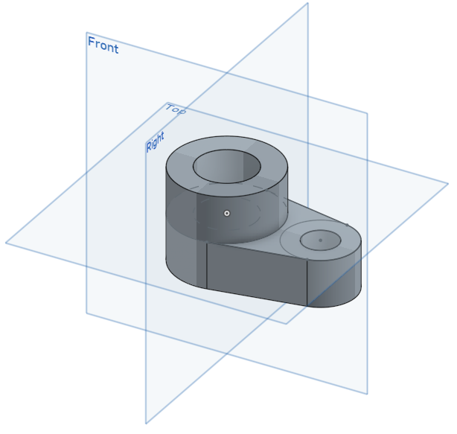

1. We can do the same for removing material. Use the smaller circle in the sketch to remove ½” of material (satisfies Design Requirement B):

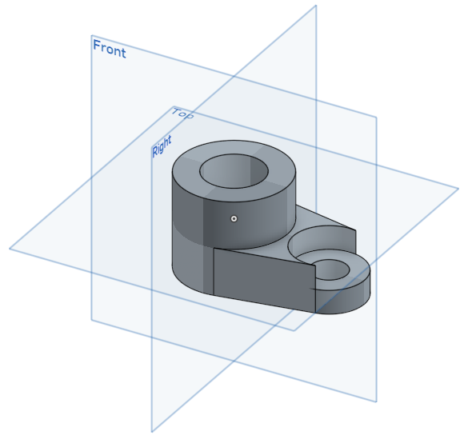

1. Finish the part by adding ¼” fillets to the sharp edges (satisfies Design Requirement C).



Now let’s look at method (b). This method uses the Use tool .

1. Let’s say you extruded the main body upwards, instead of downwards:

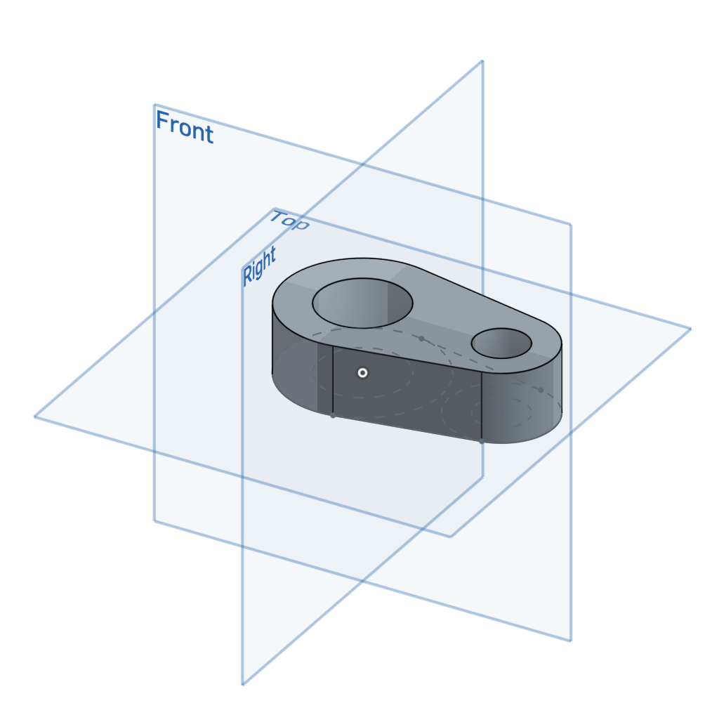

1. Make sure that your first sketch is visible by hovering over and clicking on the “slashed eye” icon . Now make a new sketch on the upper surface. Click on the Use tool  and select all the circles. The circles should appear black on the new sketch:

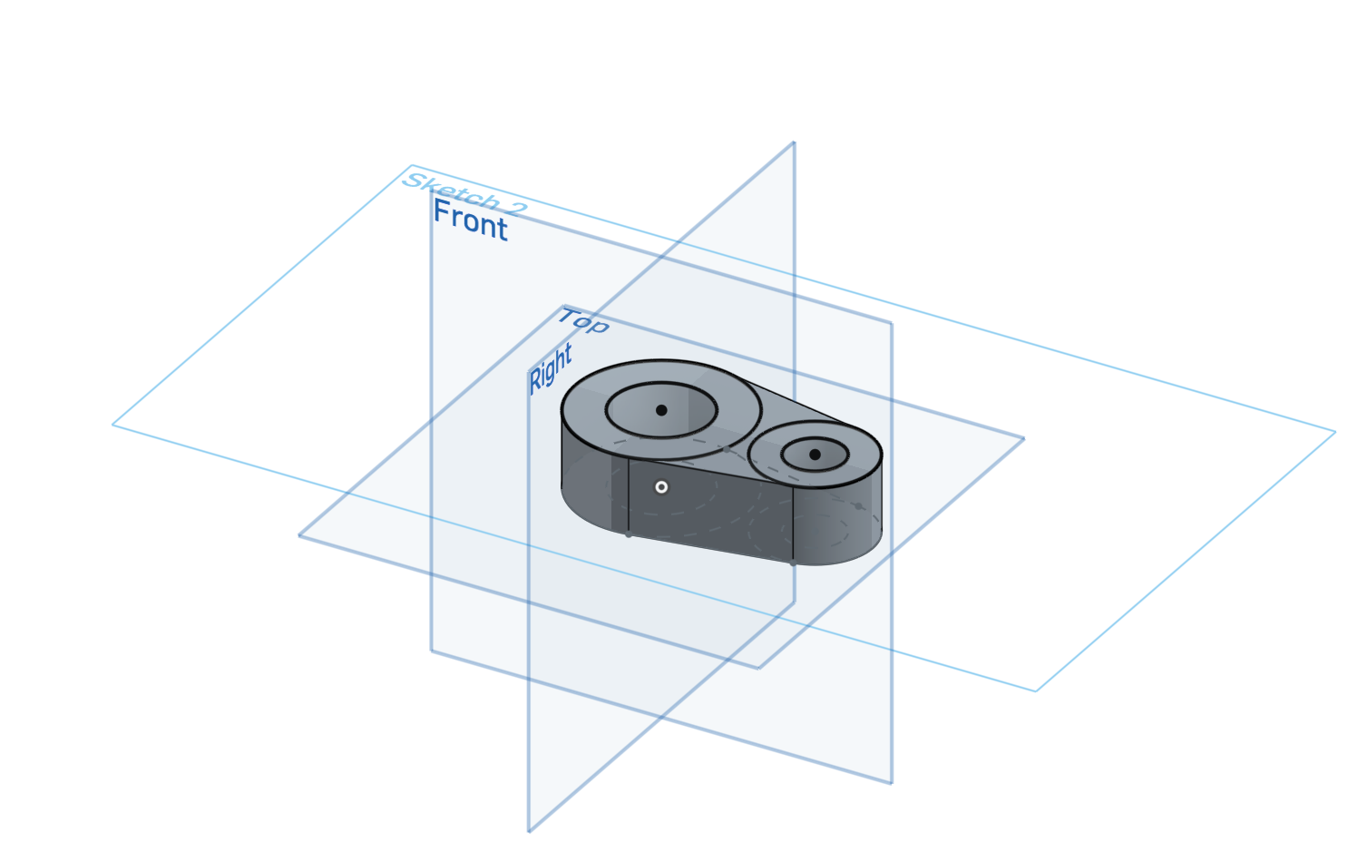

1. Extrude the larger circle upwards 1” and the smaller circle downwards ½” (satisfies Design Requirement B). Make sure the second sketch is visible during the whole extrusion process.
2. You should end up with the same model as in 10a:

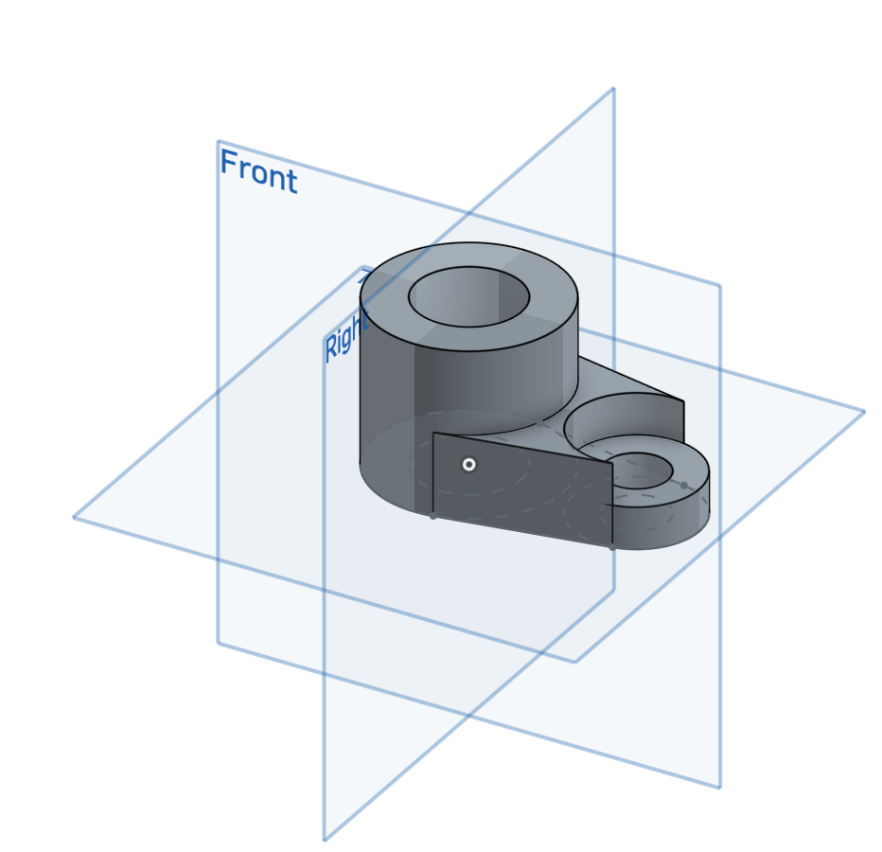

1. Finish the part by adding ¼” fillets to the sharp edges (satisfies Design Requirement C). Note that the entire model sits on top of the Top plane, unlike the model in method (a). Unless the model is symmetrical about the Top plane, most people prefer to use the Top plane as the base of the model. If you prefer to use the Top plane as the base for your model, we recommend you use this method.

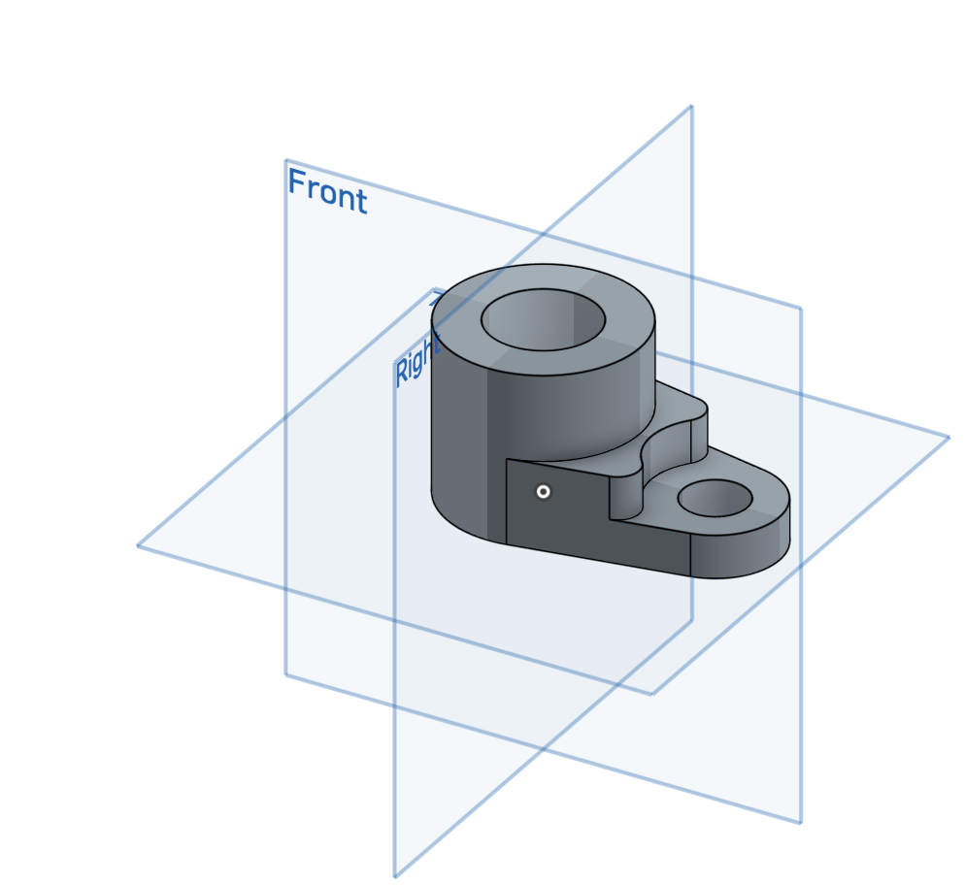

# Summary

Let’s take a second to reflect what we learned in this lesson.

1. We learned about how dimensions and constraints help define design intent.
2. We learned how to make accurate parts using:
   1. different extruding options
   2. planes
   3. fillets and chamfers
   4. multiple sketch regions

Next week we will learn about multi-body parts, where design intent will become even more important!